Grammar
Exercise 1.
Fill in the table with the words from the box. You may use some words more than once.

sandwiches
rice
three hamburgers
ten eggs
soup
pepper
salt
four milkshakes
cakes
bananas
onions
carrots
mushrooms
bread

We need … | We need some… | Do we have any…? | We don’t have any …

Exercise 2.
Fill in the sentences with some or any.

- Are there _________ sandwiches in her lunchbox? Yes, there are _________.
- I’ve got _________ pepper but I haven’t got _________ sault.
- I want _________ fresh eggs; have you got _________?
- You have a lot of apples; please give me _________.
- Please, give me _________ more cake. I’m sorry but there isn’t _________.
- I can’t see _________ cars in the street, but I can see _________ people.
- She can’t buy ______ milk as she hasn’t got _________ money.
- Ask him for _________ paper. I haven’t got _________ in my desk.
- Do you need _________ markers? No, thanks. I’ve got _________.
- Is there _________ water in the jug? There isn’t _________.
- There is _________ tea in the kitchen, but there isn’t _________ milk.
- He wants _________ more pudding. Give him _________.

Exercise 3.
Put the following sentences into interrogative and negative form.

- I have got some milk in my fridge.
__________________________________________________________________________________________________________________________________________________
- He is buying some carrot.
__________________________________________________________________________________________________________________________________________________
- They want some juice.
__________________________________________________________________________________________________________________________________________________
- She is cutting some apples.
__________________________________________________________________________________________________________________________________________________
- We have got some mushrooms.
__________________________________________________________________________________________________________________________________________________
- They are drinking some tea.
__________________________________________________________________________________________________________________________________________________
- There is some chocolate in my drawer.
__________________________________________________________________________________________________________________________________________________

Exercise 4.
Fill the sentences with how many or how much.
1. _______bananas do you eat every day?
2. _______aubergines do we need for this dish?
3. _______water do you drink a day?
4. _______hours a day do you watch TV?
5. _______ time do you need to finish the housework?

Exercise 5. ‘How much/ many ….. have you got?
Ask questions about products in the fridge using correct question form.
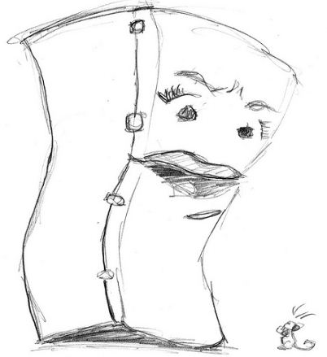
Sandwiches
rice
hamburgers
eggs
soup
pepper
salt
milkshakes
cakes
bananas
onions
carrots
mushrooms
bread

Exercise 6. Cross out the odd word. Explain your choice.
1. Coke - water - coffee - salad
2. pie - cake - steak - ice cream
3. aubergines - peaches - peppers - carrots
4. apricots - apples - spinach - cherries
5. dessert - salad - starter - main course

Speaking

Task 1.
Work in pairs.
Student A, You are at greengrocer’s and you want to buy some fruit and vegetables from the picture below. Ask a greengrocer about the products. Use the prompts given.
Have you got any… ?
How much is/are… ?
I’d like some…
Student B, You are a greengrocer. Make up prices for the fruit and vegetables below and
answer your customer’s questions.
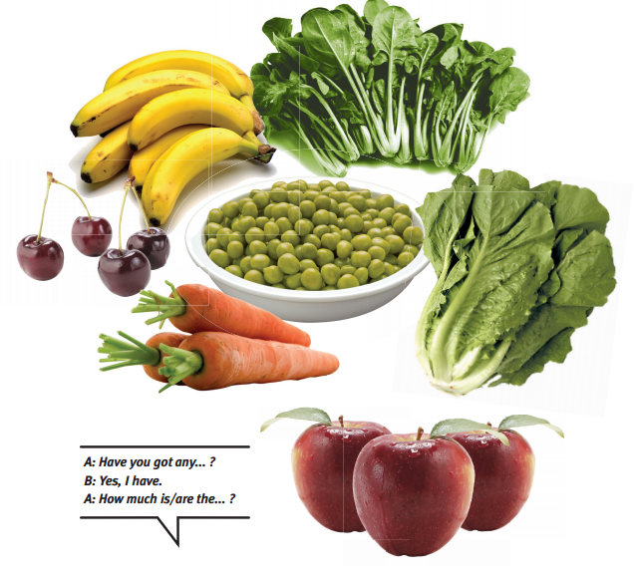

Task 2
Cooking time!
Use the presentation ‘What would you cook?’.
Follow the instructions on slide 3.
Ask your students to prepare the presentation of their own recipe as a homework.
Task 1.
Read the text and decide if the statements 1-6 are True or False. Write T for True or F for False in the boxes.

Reading
Discuss
- What is the weather usually like in your region? In summer/winter/autumn/spring?
- What is your favorite season? Why?

Read the text and mark the statement below as True or False
Do you feel the need to talk about how cold the weather is in December or how hot it is in May? Don’t worry. You’re not alone. Everybody around the world thinks of it at least once a day and it is a worldwide topic of conversation with friends, strangers and people across the Net.
Talking about the weather
People have been making guesses about how the weather might change for years. In the past, cavemen used to look for signs to follow the seasons and weather patterns. Later, farmers gathered together, pointed to the skies and shared their worries about what the wrong weather would do to their crops.
When people started living in cities, their interest in the weather continued to be as strong as ever and they invented new ways to make predictions. Now, weather reports are readily available for everyone. There are telephone numbers you can dial for an immediate weather report as well as other sites on the Net that will message you the temperature or send you an e-mail about daily weather predictions.
Knowing about the weather is useful when you want to talk with someone but have nothing to talk about. It’s a great way to start a conversation and to make small talk. The English are famous for it. As soon as two Englishmen shake hands, they start talking about what they already know – if it is hot or cold.
Some people believe that talking about the weather is a waste of time. After all, you can’t change the weather. Even so, it’s something we all share as it affects our lives. It is also a bridge taking us from small talk to more meaningful communication.

1. There is not one person who doesn’t think about the weather at least once a day.
2. Cavemen weren’t interested in the changes of the weather.
3. There are more ways to find out about the weather today than in the past.
4. People talk about the weather when they have nothing else to talk about.
5. Englishmen are famous for shaking hands.
6. Some people believe that there is no point talking about the weather.

Project

Observe the weather for 7 days and make notes in the table below. After finishing your observation write a report about the weather change. Add information about activities you think the weather was good for.

Day/Date | Temperature | Clouds | Precipitation | Wind
1.
2.
3.
4.
5.
6.
7.

My weather observation

E.g.: Today the temperature is 13 degrees above zero. it is warmer that yesterday. But the sky is full of clouds and it is raining. The strong wind is blowing…
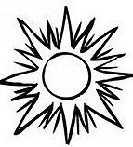
_________________________________________________________________________________________________________________________________________________________________________________________________________________________________________________________________________________________________________________________________________________________________________________________________________________________________________________________________________________________________________________________________________________________________________________________________________________________________________________________________________________________________________________________________________________________________________________________________________________________________________________________________________________________________________________________________________________________________________________________________________________________________________________________________________________________________________________________________________________________________________________________________________________________________________________________________________________________________________________________________________________________________________________________________________________________________________________________________________________________________________________________________________________________________________________________________________________________________________________________________________________________________________________________________________________________________________________________________________________________________________________________________________________________________________________________________________________________________________________________________________________________________________________________________

Grammar

Exercise 1.
Use the prompts to make the sentences in Present Continuous.
1. John / cook / pasta / at the moment
2. Diana / get / married / in / a / few months
3. It / rain / outside
4. I / stay / with a friend / for a few days

Exercise 2.
Circle the correct words.
1.I never go / am never going shopping on Saturdays.
2. It doesn’t usually rain / It isn’t usually raining this time of year.
3. What time do the shops open / are the shops opening every day?
4. My parents always work on Friday, but this week they go / they are going on holiday.
5. Are you always using / Do you always use the underground to go to work?
6. A / The new underground station is great.
7. I like their / theirs new flat. It’s very modern.
8. I saw a / the double decker bus yesterday.
9. Our / Ours new house is big. We like it.
. Exercise 3.
Choose: Present Simple or Present Continuous.

1. Water boils / is boiling at 100º Celsius.
- Helen usually goes / is going to school on foot.
- Harry answers / is answering the phone now.
- Now Stanley answers / is answering the phone.
- They often surf / are surfing the Internet in the evening.
- Meryl goes / is going to school by car today.
- Grandparents cook/are cooking together at the moment.
- Simon is a great painter. He paints/is painting great.
- Listen! Sarah sings / is singing in the hallroom.

Exercise 4.
Open the brackets using Present Simple or Present Continuous form of the verbs.
- Where ______________ you usually ______________(spend) your summer holidays?
- Clare _______________(not / watch) TV very often.
- Turn off the computer. You ______________(not / use) it.
- My friends ______________ (leave) to New York tomorrow.
- Mr. Smith ______________(take) very good photos. Look! He ______________(take) a photo of you!
- The sun usually ______________ (shine) at the weekend. But today it is ______________ (rain).
- Sam ______________ (call) her grandmother now. He ______________(call) her every day.

Exercise 5.
Translate the following sentences using Present Simple or Present Continuous.
- Я святкую Новий Рік та Різдво разом з родиною, але цього року ми святкуємо з нашими друзями.
- Я готую салат та снеки для сьогоднішньої вечірки.
- Мій молодший брат завжди робить листівку для мами на 8 березня.
- Мої друзі завжди прикрашають кімнату, коли влаштовують вечірку-сюрприз.
- Мій тато складає вірші на всі свята і ми разом вчимо та декламуємо їх.
- Кожної суботи я прибираю квартиру, але сьогодні я їду за місто, бо настали канікули.
- Щоп’ятниці я йду до музичної школи, а потім - у басейн.
- Люди в США святкують День подяки, а в Україні – ні.
- Зазвичай школярі готують святковий концерт для мам на День Матері.
- Ми фотографуємось у новорічних костюмах кожного року біля ялинки. Цього року у мене костюм ельфа, а моя сестра – Рапунцель.

Exercise 6
My typical day vs my B-day
Think about the difference between your typical day and your birthday. Make the list of activities and compare them with your classmates. What is similar and what is different?

My usual day My Birthday
I wake up at 6:30 I am sleeping till noon

Reading

Task 1.
Read the text and complete the table below

Dear …,
Hi! How are you? Sorry for not writing back for so long. I’m very busy here in Oslo.
Of course, I miss all my friends in London. I remember how we all used to go to the shopping centre after school. We had lots of fun, especially when Mark was with us. He really made us laugh. I can’t wait to come back and see everyone again.
Here, we usually get together at my friend Alfred’s house and play computer games after school. That’s also fun, but it’s just not the same. Guess what! We go snowboarding every Saturday and Sunday here. So, I can do many cool tricks now! When I come back, we can go snowboarding together and I can teach you some. It’s a lot like the skateboarding we used to do on Saturdays, but on snow. Of course that makes it more difficult, too.
Now, let me tell you about my classes. Do you remember how I used to be really good at Maths and Chemistry? Well, I’m still good at Maths but not Chemistry. It’s just too difficult here. Or maybe I just don’t study enough. Actually, I failed a Chemistry exam last week. Can you believe it? Oh, I’m also very good at English here. Ha, ha!
Anyway, I have another exam tomorrow so I need to start studying. Write back soon and tell me all your news. And don’t forget to say hello to everyone!
Bye for now,
Tom

Question | NOW | IN THE PAST
Where does/did Tom live?

Where does/did Tom hang out on weekdays?

What does/did Tom do at the weekend?

What school subjects does/did Tom do well in?

Task 2.
Write a reply to Tom and tell how your life is going at the moment. Compare you present and last year activities.
________________________________________________________________________________________________________________________________________________________________________________________________________________________________________________________________________________________________________________________________________________________________________________________________________________________________________________________________________________________________________________________________________________________________________________________________________________________________________________________________________________________________________________________________________________________________________________________________________________________________________________________________________________________________________________________________________________________________

Bingo!
Cut out cards and give them to the Ss. Name the second form of the verb and your students need to find the first one and cross it out. The first student to cross the line (→↓→↑) says ‘Bingo!’

become | catch | tell | eat
find | get | go | know
make | forget | see | spend
put | run | take | do

become | catch | tell | eat
buy | fall | have | ride
make | forget | see | spend
sleep | swim | tell | wear

become | catch | tell | eat
come | forget | leave | say
make | forget | see | spend
be | drive | give | meet

be | drive | give | meet
buy | fall | have | ride
come | forget | leave | say
sleep | swim | tell | wear

Count to 10!
Play the game with your Ss. This game can easily be adapted to any teaching need.
You give your students, an exercise which they need to translate using correct grammar/ vocabulary etc. The aim of the game is to get 10 correct answers in a row.
If students make mistakes teacher starts counting from the beginning.

Grammar

Exercise 1
Translate following sentences into English.

- Я провів вихідні з родиною на пляжі.
- Я не плавав у річці минулого літа.
- Я їздив у гори кататися на лижах минулої зими.
- Хто був вчора на вечірці?
- Мої друзі влаштували пікнік у лісі минулими вихідними.
- Моя мама не ходила до ресторану швидкого харчування.
- Ви хворіли минулого тижня?
- Я не грав в комп’ютерні ігри вчора.
- Джон пообідав з друзями в хорошому ресторані.
- Я гуляв з друзями весь вечір вчора.
- Ми з класом відвідали «Експерементаріум» минулого місяця і нам дуже сподобалось там.
- Моя сестра не поїхала у табір, а залишилась вдома з батьками.
- Марія приготувала смачну піцу перед тим як поїхала в село.
- Минулої п’ятниці мій друг влаштував вечірку, але я не пішов туди, бо був хворий.
- Чому ти не сказав мені, що тобі не сподобався фільм?
- Коли ми їздили у подорож ми не зупинялися в готелі, а ночували у друзів.
- Коли я був у Чернівцях я відвідав всі пам’ятки міста.
- Коли ми відпочивали з палатками я кожного ранку ходив рибалити .
- Ти бачив сумного хлопчика вчора в ресторані? Чому він був сумний?
- В ресторані жінка говорила так голосно, що дитина за сусіднім столиком злякалась.

Reading
Task 1

Discuss.
Do you like music and dance festivals? Why/Why not?

Read the text and answer the questions below it.
WOMAD (World of Music, Arts and Dance)
festivals celebrate music, art and dance from all around the world. It is also a way for unknown artists to perform in front of many people and maybe become famous.
The festivals are exciting and offer a lot of different kinds of music. There are amazing music and dance performances, but also different activities and workshops for both adults and children. In the workshops people can meet the artists and learn about their culture and music. There are also special workshops
for children; they can have lots of fun and learn something new at the same time.
At WOMAD festivals there are lots of shops and stalls, too. They sell arts and crafts and food from countries all over the world. Festival goers can try lots of di erent kinds of food and learn about the countries it comes from. They can also see beautiful art from around the world. There are always lots of fun activities for people to do at the festivals. For example, at the WOMAD Festival 2008 in England there was a World of Wellbeing center. Here, festival goers could enjoy a relaxing massage.
WOMAD is a celebration of the music and culture of the world. It gives people a chance to experience sounds from around the world.
It is a special festival that will entertain and also teach you something new.

1. What does WOMAD do?
2. Why is it good for new artists to perform at WOMAD?
3. What can people do at the workshops?
4. Where can festival goers try food from different countries?
5. What could festival goers do at the WOMAD Festival 2008 in England?

Task 2

Discuss.
Would you like to visit a mysterious island?
Why/why not? What would you do there?

Read the brochure and e-mail and complete the information in circles.

MYSTERIOUS ISLAND
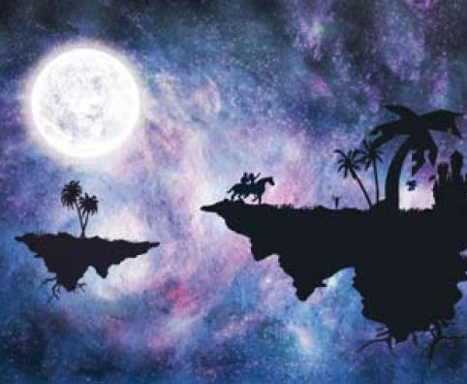
Come to Mysterious Island for an unforgettable holiday!
Swim in the beautiful waters of the Zandican waterfall as exotic birds fly over your head.
Try scuba diving. It is an incredible experience with so many different kinds of colourful fish.
Visit Kutchiskaya volcano and enjoy the fantastic view.
Go hiking, horseback riding or explore the famous Masoulaya Salt Caves.
Take a bus or a boat tour around the island.
The Mysterious Island Resort offers one tour to every customer.
A TOURIST’S PARADISE...

Dear Nathan,
We are having a great time at Mysterious Island Resort. On our first day we swam in the pool and sunbathed from morning till night. We tasted some of the local food at the resort like you suggested. It was delicious!
The next day we went swimming in the Zandican waterfall. There’s a horse riding center near the waterfall that takes you to the Masoulaya Salt Caves. Of course, we didn’t miss the chance to ride horses and visit the caves. My brother Tom and I also went scuba diving. I’ve tried scuba diving in some amazing places in my life but they were nothing like scuba diving here. The fish are unbelievable! We haven’t taken a tour around the island yet. We could do that tomorrow before we leave. I prefer the bus tour because boats make me seasick. As you can see, we’re having a great time! See you when we get back.
Bye now,
Jake
SUGGESTED
IN THEBROCHURE
NOT SUGGESTED IN THE BROCHURE

THINGS THEY DID THAT WERE ALSO SUGGESTED IN THE BROCHURE

Writing

You looked through an advert of the Mysterious Island and got interested in it. Write an email to you friend offering to spend time there together and describing activities you would do there. Use Jake’s letter as an example. Write 100-150 words.
___________________________________________________________________________________________________________________________________________________________________________________________________________________________________________________________________________________________________________________________________________________________________________________________________________________________________________________________________________________________________________________________________________________________________________________________________________________________________________________________________________________________________________________________________________________________________________________________________________________________________________________________________________________________________________________________________________________________________________________________________________________________________________________________________________________________________________________________________________________________________________________________________________________________________________________________________________________________________________________________ _______________________________________________________________________________________________________________________________________________________________________________________________________________________________________________________________ _______________________________________________________________________________________________________________________________________________________________________________________________________________________________________________________________________________________________________________________________________________________________________________________________________________________________________________________________________________________________________________________________________________________________________________________________________________________________________________________________________________________________________________________________________________________________________________________________________________________________________________________________________________________________________________________________________________________________________

Project!

Task 1
Create the map of Europe
Choose one of the countries and prepare the information about the country focusing onfollowing issues.
- Territory
- Population
- Sights
- Best time for visiting
Make notes and mark the position of the capital and the most attractive sights.
Be ready to present information to your classmates. The presentation should last up to 3 min.
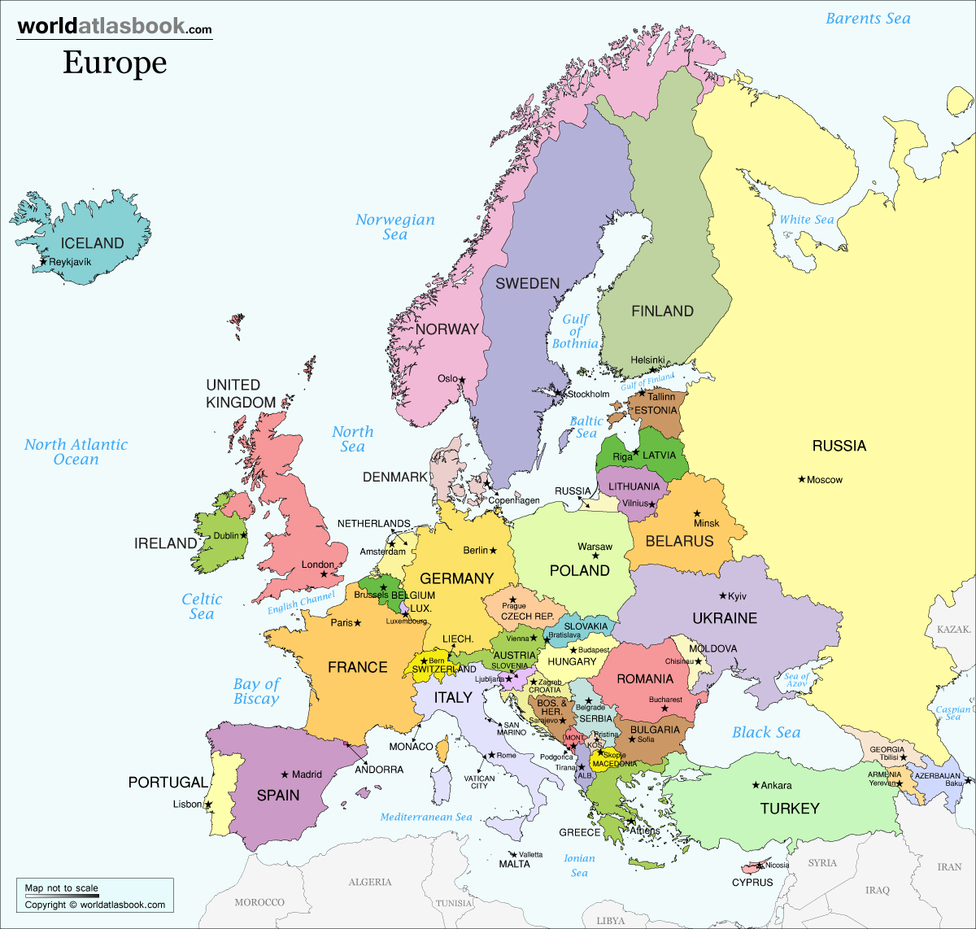

Spain
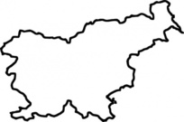

Notes:
___________________________________________________________________________________________________________________________________________________________________________________________________________________________________________________________________________________________________________________________________________________________________________________________________________________________________________________________________________________________________________________________________________________________

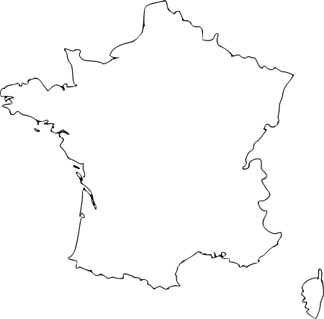
France

Notes:
___________________________________________________________________________________________________________________________________________________________________________________________________________________________________________________________________________________________________________________________________________________________________________________________________________________________________________________________________________________________________________________________________________________________

Italy

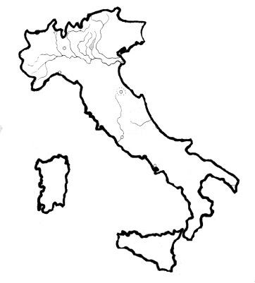

Notes:
___________________________________________________________________________________________________________________________________________________________________________________________________________________________________________________________________________________________________________________________________________________________________________________________________________________________________________________________________________________________________________________________________________________________

Germany
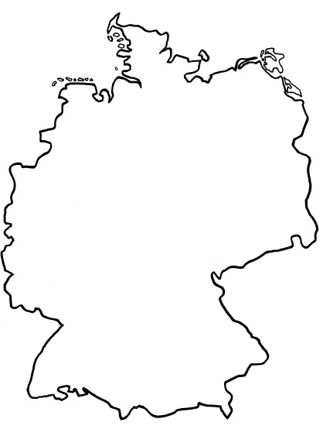
Notes:
______________________________________________________________________________________________________________________________________________________________________________________________________________________________________________________________________________________________________________________________________________________________________________________________________________________________________________________________________________

U.K.
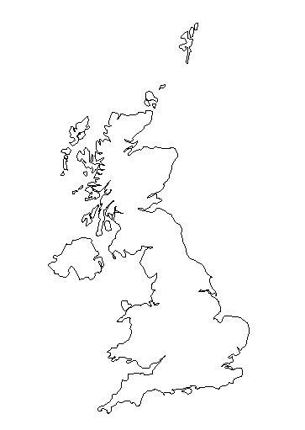
Notes:
___________________________________________________________________________________________________________________________________________________________________________________________________________________________________________________________________________________________________________________________________________________________________________________________________________________________________________________________________________________________________________________________________________________________

The Netherlands
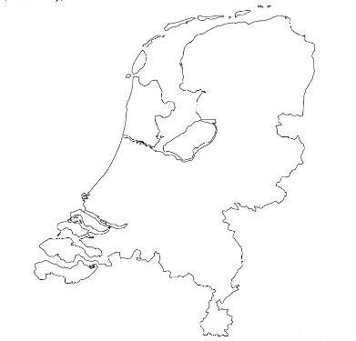
Notes:
___________________________________________________________________________________________________________________________________________________________________________________________________________________________________________________________________________________________________________________________________________________________________________________________________________________________________________________________________________________________________________________________________________________________

Denmark
Notes:
___________________________________________________________________________________________________________________________________________________________________________________________________________________________________________________________________________________________________________________________________________________________________________________________________________________________________________________________________________________________________________________________________________________________

Poland
Notes:
___________________________________________________________________________________________________________________________________________________________________________________________________________________________________________________________________________________________________________________________________________________________________________________________________________________________________________________________________________________________________________________________________________________________

Austria
Notes:
___________________________________________________________________________________________________________________________________________________________________________________________________________________________________________________________________________________________________________________________________________________________________________________________________________________________________________________________________________________________________________________________________________________________

Grammar

Exercise 1.
Fill in the comparative or superlative form of the adjectives in brackets.
- July is 15 and Jane is 5. Jane is ________ (young).
- All lakes are _______ (small) than oceans.
- My mark for the test is “perfect”, his mark is “good”. My mark is _____ (good) than yours.
- ‘Harry Potter’ is ______________ (interesting) book I read last year.
- This exercise is not easy. It is ___________ (difficult) than I thought.
- People think that it is _________ (easy) to learn German than Japanese.
- Hoverla is ________ (high) mountain in Ukraine.
- It is really hot today. I hope it will be ________(cold) tomorrow.
- Roses are __________(beautiful) than chamomiles.
- New York is _______(big) than Washington.
- He is _______ (clever) boy I know! He knows answers to all questions.
- I hate rainy weather. This is _______ (bad) weather for me.

Exercise 2.
Translate following sentences into English.

- Кімната мого брата чистіша ніж моя.
- США більше за Сполучене Королівство Великобританії та Північної Ірландії.
- Сьогодні я почуваюся краще, ніж учора.
- Хто най балакучіший у вашій родині?
- Моя сестра – найрозумніша в нашій родині.
- Китайська - найскладніша мова в світі.
- На вчорашньому концерті мій клас виступив гірше ніж інший.
- Що ти можеш робити краще за інших?
- Що ти робиш найкраще?
- Твій брат - вищи за тебе.

Exercise 3.
Open the brackets using the correct form of the adjective.
Comment on the fact. Is it True or False?

- Belarus is ______ (big) than Poland.
- China is the ________ (populated) country in the world.
- Atlantic Ocean is ________(small) than Australia.
- Trains move _______(fast) than planes.
- Nile is ________ (long) river in the world.
- France is _______ (hot) than Egypt.
- Adults learn ______(easy) than children.
- Reading a book is ________ (interesting) than watching TV.
- Playing with friends is _______ (funny) than being at home alone.
- Travelling is _______ (good) option for holidays.

Exercise 4.
Choose the correct answer. Prove your opinion.
Do you know? ( Part I)
1) Which mountains are higher?
a) the Andes b) the Himalayas
2) Which city has bigger population?
a) Kyiv b) Washington
3) Which writer is older?
a) Taras Shevchenko b) Lesya Ukrainka
4) Which country has a longer coastline?
a) Australia b) Canada
5) Which elephant is bigger?
a) Indian b)Asian
6) Which country has smaller population?
a) Germany b) Belarus
7) Which pyramids are older?
a) Egyptian b)Maya
8) Which river is longer?
a) Dnieper b) Danube
9) Which ocean is bigger?
a) Indian b)Atlantic
10) Which place is colder?
a) North Pole b) Antarctic

Exercise 5.
Answer the questions. Prove your opinion.
Do you know? ( Part II)

Which continent is the biggest in the world?
What country is the smallest in the world?
What is the highest mountain in the world?
What is the most interesting subject for you?
What is the longest river in the world?
What is the oldest building in your city/town/village?
Who is the most famous musician in your country?
What is the most popular touristic sight of your country?
Who is the most hardworking student in your class?
What is the most popular place at your school?

Reading
Discuss.
• What kind of attractions can you usually find in a national park?
• Is there a national park in your country?What is it like?

Read the text and write T for True or F for False.
1. Yellowstone National Park is only in Wyoming.
2. The park isn’t usually open at night.
3. Yellowstone isn’t a small park.
4. ‘Old Faithful’ is a famous park.
5. People can take their children to Yellowstone.

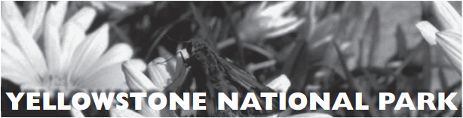
Are you a nature lover? Then you should visit the amazing Yellowstone National Park.
The biggest part of the park is in Wyoming, US, and it’s the oldest national park in the world.
It is usually open 24 hours a day and covers a huge area of 3500 square miles. There are lots
of sights and activities for the Yellowstone visitor.
Its attractions include lakes, forests, canyons, mountains, waterfalls, geysers, rivers and the largest supervolcano in North America. There are also hundreds of animals, fish, birds and reptiles there.
There are over 300 geysers in the park, but the most famous one is called ‘Old Faithful’. People visit ‘Old Faithful’ every hour to see the hot water and steam going up almost 200 feet into the air. There are many things to do at Yellowstone in winter and summer, like hiking, camping, rafting and
sightseeing. People can also go fishing there. For the younger visitors, Yellowstone organises manyfun activities and gives them the chance to learn a lot about nature and the history of the park.

Are there any of below mentioned things in Ukraine?

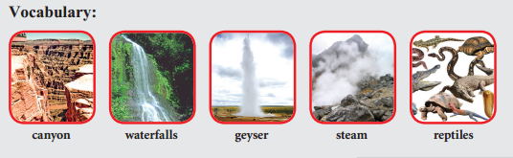
What national parks of Ukraine do you know? Prepare short presentation. Use the text above as an example.

