Grammar!

Exercise 1
Complete with the Present Simple of the verbs in brackets:
- Paul __________ (like) hanging out with friends.
- Leo and Mike _________ (play) football every day after school.
- Jake __________ (clean) the window with his Mum every spring.
- Tina __________ (prefer) studying at night.
- I __________ (have) a shower every morning.
- Catherine __________ (take out) rubbish every morning.
- We always__________ (wash) the car together.
- Jill __________ (brush) teeth twice a day.
- Mila __________ (read) magazine or newspaper every day.
- Peter __________ (have) breakfast at home.

Exercise 2
Circle the correct form.
- Does July live/lives in Africa?
- Does Pat tidy/tidies her room?
- Does Evan goes/go to the Supermarket?
- Do Andy and Ann do/does the washing up together?
- Do you read/reads this newspaper?
- Am/Are I a student?
- Is/Are they in the room?
- Does Jane play/plays football at weekends.

Exercise 3
Write the following sentences in the Negative Form:
- Tom has a car. _________________________________________________________________
- We spend time together after school._______________________________________________
- Mary loves volleyball. ___________________________________________________________
- They wash the car themselves. ____________________________________________________
- Paul washes up in the kitchen. ____________________________________________________
- I brush my teeth in the kitchen. ___________________________________________________
- I always have shower in the evening. _______________________________________________
- Ann hates tidying her room . ______________________________________________________
- Mike cleans the window. ________________________________________________________
- Betty reads magazines. __________________________________________________________

Exercise 4
Fill in the gabs with the correct form of the verbs:
- Do you ____________ (speak) French?
- Kate ____________ (not know) him very well.
- Most shops _____________ (close) at 22:00.
- The 6:35 train _____________ (not/ stop) here.
- What ____________ George usually ____________ (have) for breakfast?
- Maria ____________ (read) very interesting books.
- My uncle ________________ (wash) his car himself.
- The children __________________ (do) the washing-up every day in summer.
- Jane ____________ (not/work) in the office every day.
- What ____________ Melissa ____________ (do)?She ___________( not/work). She's a pupil.
- My elder sister _____________ (not help) me with my homework.
- The children usually _____________ (eat) in the school canteen.
- Tim ____________ (like) hanging out with his friends.
- What time _____________ (the play/ start)?
- Birds of Europe _____________ (fly) to Africa every winter.
- Pam _____________ (not/wear) skirts.
- It often _____________ (rain) here in spring.
- Peter _____________ (not/speak) English well.
- My mother _____________ (drive) us to school.
- Some people _____________ (not/ like) parties and their birthday.

Exercise 5
Match the activity with the picture and put them in the right order.
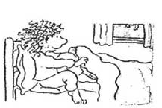
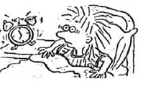
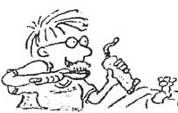
- Wake up
- Get up
- Brush the teeth
- Comb the hair
- Take a shower
- Go to bed

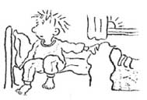
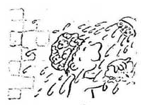
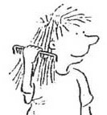

Exercise 6
Describe your typical day using the prompts above
____________________________________________________________________________________________________________________________________________________________________________________________________________________________________________________________________________________________________________________________________________________
___________________________________________________________________________________________________________________________________________________________________________________________________________________________________________________________________________________________________________________________________________________________________________________________________________________________________________________________________________________________________________________________________________________________________________________________________________________________________________________________________________________________________________________________________________________________________________________________________________________________________________________________________________________________________________________________________________________________________________________________________________________________________________________________________________________________________________________________________________________________________________________________________________________________________________________________________________________________________________________________

Exercise 6
Read the sentences and decide whether there is a mistake.

1. I am not loving you.
2. Do you owning your house?
3. I am not knowing the answer.
4. Bob looks for a new job.
5. He is not seeming very happy today.
6. Are you liking pasta?
7. I think it’s a great idea.
8. I am feeling it is a good proposal.
9. At the moment, my friend is attending an dance class
10. I understand what you are saying.

Exercise 7
Open the brackets using Present Simple or Present Continuous.

- Jane usually (play)_____ but today she (play)_______ poker.
- What language they (speak) _______ in Australia?
- What language he (speak) ________ now?
- My brother always (tell) me the truth, but I see that she (tell) _______ a lie now.
- I usually (go) _______ to school by bus. .
- She, as a rule, (wear) _______ jeans, but today she (wear) a dress.
- I (study) _______ a lot every day. Don`t worry! I (know) _______ what I (do) _______.
- My teacher (explain) _______ homework now.
- You (eat) _______ vegetables every day?
- She (hate) _______ pudding but he (eat) one at the moment.

Exercise 8
Translate following sentences into English using Present Simple or Present Continuous.
- Вона не чує, що каже вчитель.
- Він каже, що дуже її любить.
- Я читаю книжку, але не розумію про що вона.
- зазвичай я пю каву вранці. Що ти пєш зараз?
- Я хочу бути вдома прямо зараз.
- Я бачу його зараз через вікно.
- Фіона бачить що на вулиці йде дощ.
- Я вважаю, що ідея безглузда. .
- – О котрій відлітає твій літак? – О 14.15
- – Куди ти біжиш так швидко? – Я не хочу пропустити свій автобус.

Exercise 9
Imagine that today is your perfect day. Put down 10 sentences to compare in your usual and perfect day.

Typical day | Today

Miming!

Split into teams of 3. Choose one of the activities below and mime it to your classmates. You have 30 sec. Team, which wins gets a point.

paint cinema | start a concert | draw the guitar
play drama | play rollerblading | have a table tennis
have pictures | teach skateboarding | brush board games
go to the football match | play painting | tidy skateboard

Game Time!

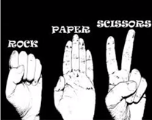
Discuss.
Look at the picture. Do you know the rules of this game?
Put them down using following verbs:
cut break cover

____________________________________________________________________________________________________________________________________________________________________________________________________________________________

Video

Watch an episode of popular sitcom ‘The Big Bang Theory’. Do they follow your rules??
https://www.youtube.com/watch?v=_PUEoDYpUyQ

Check the meaning of the following words and phrases:
Lizard
What a freak is that?
improvement of the
hail
disprove
vaporize
Can you repeat that?
got it
screw with somebody

Watch an episode again and number the lines of the rules.

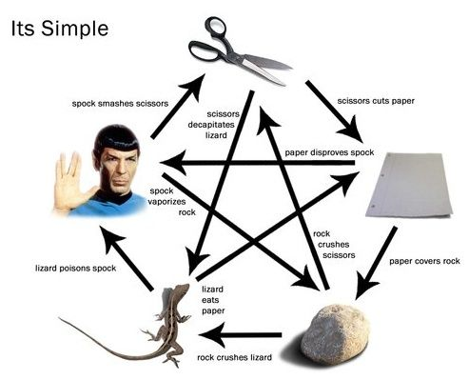

Work in pairs or small groups.
Choose one of the following games and be ready to explain its rules without naming them. Let your classmates to guess the game.

football
hide-and-seek
cards
tic-tac-toe

Speaking!

Do you like to do these activities on weekends?  Check your answers and compare them with a partner.  Yes |  | No
Go to the movies
Play computer games
Eat out
Go shopping
Watch sports on TV
Go to the park
Do crossword puzzles
Read the weekly newspaper
Go fishing
Listen to the classical music
Grammar!
Exercise 1
Complete the sentences with the Present Simple or the Future will of the verbs in brackets
1. When he (finish) _______ his work, he (go) _______ out.
2. you (do) _______ me a favor? you (turn) _______ the computer off?
3. As soon as I (arrive) _______ home, I (call) _______ you.
4. You (give) _______ me the book?
5. I (try) _______ to repair my computer before I (buy) another one.

Exercise 2
Match the beginning and end of the sentences. Use 0 Conditional

If you don’t sleep,
If you boil water,
If you face north,
If you don’t drink anything,
If you heat metal,
If you don’t study,
If you miss lunch,
If you don’t save any money,
If you travel south
If you study hard
If you freeze water,
If you break a mirror,
it turns into steam.
you’ll pass the test.
it turns into ice.
it expands.
you’ll fail the test.
you’ll get hungry.
you get tired.
you reach Antartica.
you’ll get thirsty.
you won’t have money to spend.
west is to your left.
you’ll get 7 years’ bad luck.

Exercise 3
Open the brackets using correct form of the verbs. Use 0 Conditional.
- Plants die if they ________ (not/ get) enough water.
- If the machine ________(drive), don’t touch it.
- If we ________(be) late for lesson, our mother gets irritated.
- If you ________ (not / eat) on time, you get hungry.
- If you don’t study, you ________(can) get good marks.
- The sun burns if the weather ________(be) hot.
- If someone enter the building, the alarm ________ (go) off.

Exercise 4
Make sentences using given words, Use 1 Conditinal.
- she/have a problem/ call her mother.
- he/not go out now/he be late.
- Use Googlemaps/get lost.
- Brazil win World Cup/be a national holiday.
- The weather be snowy/have nice Christmas.
- Scholl results get better/we go camping with the class.

Exercise 5
Complete the sentences with your own ideas. Use 0 or 1 Conditional.
- I will see you on Friday…
- If the lion escapes from the zoo…
- If we find a treasure…
- Mother doesn’t like…
- If school closes…
- My family will proud of me…
- Out school team will become a champion…
- If my sister takes my clothes…

If-story
Create your own if story of 10-15 sentences. Choose one of the beginnings below and develop your idea using conditional sentences.
If I live in New York….
If I become the President of Ukraine…
If I have my own apartment….
If I win the lottery….
_____________________________________________________________________________________________________________________________________________________________________________________________________________________________________________________________________________________________________________________________________________________________________________________________________________________________________________________________________________________________________________________________________________________________________________________________________________________________________________________________________________________________________________________________________________________________________________________________________________________________________________________________________________________________________________________________________________________________________________________________________________________________________________________________________________________________________________________________________________________________________________________________________________________________________________________________________________________________________________________________________________________________

Fortune telling!

What do people do to predict their future? Do you know anything about following things?
- Cards
- Tea leaves
- Psychic
- Coffee
- Gypsy

Have you ever used anything? Do you believe in it?

Make predictions for your desk-mate. Open the bracket using will or be going to in the correct form.

- You ________________ (get) “A” in English..
- You ________________ (travel) around the world.
- You ________________ (meet) lots of interesting people.
- Everybody ________________ (love) you.
- You _______________ (not have) any problems.

Reading!
Discuss
Do you agree with the following statements? Explain.
- In 100 years, all people will work from home.
- In 100 years, children will live at schools.
- In 100 years, teachers will be robots.
- In 100 years, people will not travel the world.
- In 100 years, people will live on other planets.

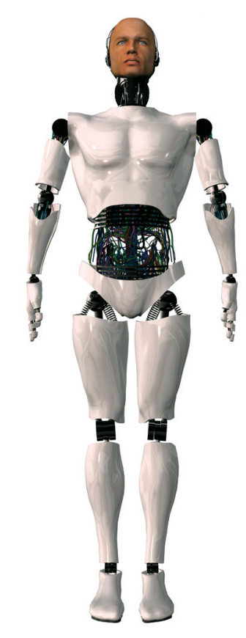
Look at the picture. Who or what do you think Ros is?

ROS (Robotic Office Servant)
I don’t really mind my job, and sometimes I even like it. I work at the LUX Power Company in Wyoming. For some people, my job might seem boring, but I just enjoy a good day of work. The office opens around 9:00am, but before that I’m rolling around turning on computers and cleaning up before everyone gets in. During the day, work isn’t hard, and can even be lots of fun. I often have to type up letters, solve Maths problems, make coffee, write e-mails, and sometimes, my favourite part, I get to go into the room with a red ‘X’ to fix the computers.
The people here are very nice. There’s Dr Arnold, he’s the head scientist. I like to call him ‘Boss’, which I think is funny because it rhymes with my name ‘Ros’! Dr Arnold is always very interested in my opinion about things. There are Dr Sally the Nuclear Physicist, and Barry the Technician. Dr Sally’s a really sweet girl and she’s very nice to me. Every day around 13:02pm, everyone usually goes to lunch. I normally stay in the office and continue working, but one day Sally turned to me and asked, 'Hey Ros, would you like to join us for lunch?' I got so excited, but Barry just laughed and answered, 'He’s not going anywhere. He needs to finish fixing the computer (Barry was supposed to do this but didn’t!). What’s he going to do with us anyhow, drink oil?' Everyone just laughed and walked out.
That made me feel very sad. As you can see, I don’t really like Barry very much. I mean, he doesn’t even know my name! What Barry doesn’t understand is that, like everyone else, I too have feelings. A polite ‘please’ or ‘thanks’ once in a while would really help our relationship. He could start by learning my name.
Maybe I’ll talk to him about it tomorrow. If I’m reasonable, I think he’ll understand. Well, it’s getting late, and I have to continue working. I’ve got a list of 9 more chores to do before the office opens up tomorrow and I don’t want to be late. First thing on the list — to fix my left eye. That’s been bothering me for over a week now, but I’ve been too busy to correct it. Here’s the pin. 1, 2, 3 turns—there, that’s better, isn’t it!

Read the text and answer the questions. Choose a, b or c.
- From reading the text what do we understand about Ros?
a. He is human.
b. He is a kind of robot.
c. His colleagues don’t like him.
- When does Ros start work?
a. when the office opens
b. after everyone gets to the office
c. before the office opens
- Who is interested in what Ros thinks about things?
a. Dr Sally
b. Dr Arnold
c. Barry
- Why doesn’t Ros like Barry?
a. because Barry doesn’t know his name
b. because Barry does things that hurt his feelings
c. because Barry didn’t fix the computer
- Ros probably
a. doesn’t stop working even at night.
b. works only during the day.
c. doesn’t work very hard.

Discuss
  - Is it good to have robot at home?
  - Will all people have robots at home in 50 years?
  - Can robots become independent?
  - Will robots replace people at workplaces?
  - Would you like to have robot at home?

Imagine that you own ROS. What will the robot do for you every day? Put down 1 sentences.
- ____________________________________________________________________
- ____________________________________________________________________
- ____________________________________________________________________
- ____________________________________________________________________
- ____________________________________________________________________
- ____________________________________________________________________
- ____________________________________________________________________
- ____________________________________________________________________
- ____________________________________________________________________
- ____________________________________________________________________

Grammar!
Exercise 1
Purr the following verbs into past simple form

Catch ___________
Spend ___________
Swim ___________
Take ___________
Love ___________
Fly ___________
Throw ___________
Sent ___________
Cry ___________
Shine ___________
Meet ___________
Come ___________
Choose ___________
Lose ___________

Exercise 2
Read the text and put the word in the brackets into the correct form of Past Simple Tense.
It _____ (be) the summer of 1866, when some strange events in the oceans ___________ (frighten) people all over the world. Those who _________ (work) at sea were especially worried. There ______(be) rumors about ‘an enormous thing’, a huge sea moster which ___________ (appear) near ships in different places. Nobody ________ (see) something like it before. The creature ______(be) as long as two hundred feet and _______ (move) extremely quickly – one day sailors ______(spot) it off the coast of Australia, and three days later, there _____(be) news of a collision between the moster and the ship and, six month after that, something very disturbing _________(happen) – the creature ______(hit) two ships in the Atlantic.
On both occasions the passengers ______(be) saves but the public __________ (become) very angry and frightened because of what __________ (happen). Nobody _______ (want) to travel between Europe and the United States because it _______ (not be) safe. The American government_________ (decide) to take action and _______ (give) orders to find the creature. The best American warship, the Abraham Lincoln, ______ (be) soon armed under the command of Captain Farragut and _______ (prepare) to leave for the North Pacific where people _____ (see) the creature for the last time.

Answer the questions.
- Why were people worried?
- Where did sailors see the monster?
- Did anybody get injured?
- Who decided to catch the creature?
- Where did people see the creature for the last time?

Exercise 3
Use the words below and create your own version of the story.
waves Ocean to shoot whale SOS (Save Our Souls) sailors to come across island treasure curse passengers government to land
Captain Farragut and his brave crew left America on …
___________________________________________________________________________________________________________________________________________________________________________________________________________________________________________________________________________________________________________________________________________________________________________________________________________________________________________________________________________________________________________________________________________________________________________________________________________________________________________________________________________________________________________________________________________________________________________________________________________________________________________________________________________________________________________________________________________________________________________________________________________________________________________________________________________________________________________________________________________________________________________________________________________________________________________________________________________________________________________________________

Exercise 4
Complete the sentences with the Past Simple of the verbs in the box.
tell be send call find
1. A: Why ______you at work at the weekend?
B: Because my boss ______me to come to work.
2. A:_____ your sister you?
B: No, she______ me an e-mail.
3. ______you______ your keys?

Exercise 5
Complete the sentences with the Past Progressive of the verbs in the box.
feel study put r ain
1. It _______ all day yesterday.
2. I _______ for my exam at 10 o’clock last night.
3. She ________ dizzy so she sat down.
4 .As she _________the flowers in the vase, she saw the broken chair.
Exercise 6
Complete the sentences with the Past Simple or the Past Progressive of the verbs in brackets.
1. As soon as the merchant (take) _______ the snake out of the basket, I (feel) _______ dizzy.
2. We (have) _______ dinner when the lights (go) _______ out.
3. While he (return) _______ home, he (see) two men outside his house.
4. While I (walk) _______ through the market, the shopkeepers (talk) _______ to me.

Exercise 7
Open the brackets using the correct tense form.
- When Jake opened the box, he (find) __________________ a surprise.
- While Mary was setting the table, her Mother (check) _________________ her homework.
- While Sam was watching a horror movie, somebody (knock)___________
on the door.
- Lina fell asleep while he (watch) ___________________a new comedy film.
- When the tree (fall)____________on the road, Mike was working on the garden.
- I am reading right now. I (read) ________________ at this time yesterday.

Exercise 8
Translate following sentences into English using correct tense form.
- В той час як я спав, мій брат намалював мені вуса.
- Ми готували вечерю, коли зателефонувала бабуся.
- Коли музика закінчилась, гості все ще танцювали.
- Я приміряла нову сукню, а моя сестра питала в продавця ціну.
- Коли спортсмен першим перетнув фінішну лінію, його тренер почав стрибати з радощів.
- Я знайшов дивний ящик ,в той час як гуляв вздовж берега.
- Співачка танцювала та співала протягом всього концерту.
- Спортсмен сконцентрувався, розбігся та стрибнув. Його тренер весь час дивився на нього.

Exercise 8
What were you doing when…?
Answer the questions using the correct tense form Past Simple or Past Continuous.
- …when your Mum called you?
- …when everybody was watching Football Cub?
- …when aliens landed on your backyard?
- …when somebody knocked on the door?
- …when Columbus discovered America?

Storytelling!

It’s unbelievable!

Create your own story using past Simple and Past Continuous Tenses. Work in group of 3 or 4. The table will help you to consider the main issues of each story. Make notes of your ideas and present your story to the class.
Time/place
Character(s)
Activity
(What was doing?)
Location
Unexpected event (what happened?)
After that…
Then…

Finally/ At last…

The end

Reading!

Look at the pictures? What do you know about these people?
Read texts and find out whether you were right.
Jamie Oliver
Jamie Oliver is a very popular British celebrity chef.
Jamie was born in 1975 in Essex, England. The BBC discovered Jamie when he was a young chef in the River Café restaurant in London. His first TV series was very successful; Jamie’s style was different from other TV chefs and viewers liked him a lot. Next came Jamie’s Kitchen; in that show, he combined cooking and working with troubled teenagers and made an exciting reality show. Jamie trained the teenagers at his restaurant and helped them improve their lives. Jamie is also famous for his work to improve school dinners in the UK through his programme Jamie’s School Dinners. Thanks to Jamie, school menus have changed a lot and become much healthier.

Usain Bolt
Usain Bolt is one of the most famous sprinters in the world.
He was born in 1986 in a small town in Trelawny, Jamaica. From a very early age, he had a great passion for sports and he used to spend his time playing cricket and football in the street with his brother. When he was in primary school, he took part in the national running competition and had the chance to show his sprinting ability. So, by the age of twelve, Usain was the school’s fastest runner over 100 metres. In 2002 Usain took part in the World Junior Championships, where he managed to win the 200 metres gold medal, making him the competition’s youngest-ever gold medalist. Since then, his career has taken off. Today, Usain holds the world record for the 100 and 200 metres and, along with his teammates, for the 4x100 metres relay. He also holds the Olympic record for all these three races. At the 2008 Beijing Olympics, he won three gold medals and became the first man to set three world records in three races at a single Olympics. Usain was given the nickname ‘Lightning Bolt’. Usain is also involved in charity work and, apart from donating money, he has also launched a fashion line that will help support charities in Jamaica.

Read the texts and complete with the correct name Jamie or Usain.
1. has done something nobody has done.
2. won an event when he was a boy.
3. had his own show.
4. made changes that affect children’s health.
5. trained young people.
6. helps his country by doing charity work.

Who do you think is a good example to follow in Ukraine? Why?
Prepare information about this person and present it to you classmates.
Consider following issues:

- biography
- reason to be famous
- activities
- current occupation

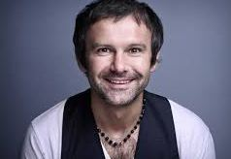
Reading!
Discuss
Look at the picture. How do you think what the story is about?
Skim the text. Did you guess right?

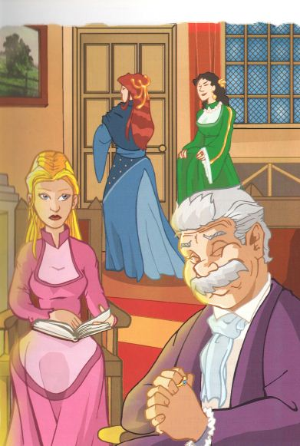
Once upon a time in a country far away live a very rich merchant. In fact, the merchant was the richest man in town. The merchant and his wife had three sons and two daughters. The family lived in a very big house with many rooms and servants. The merchant’s wife gave birth to another daughter. The youngest daughter was very beautiful, so everyone called her Beauty. Soon after Beauty’s birth, her mother died. As she grew Beauty became prettier and prettier. Her sisters were very jealous because everyone admired her. They were very mean to her and never played with Beauty. Beauty’s brothers liked her, but they were always busy, so they didn’t play with her either.
The merchant’s older daughters were very spoiled and always asked their father for gifts. Beauty never asked her father for anything, so she became his favorite. Beauty’s sisters often went for parties, but Beauty stayed at home with her father. Beauty loved books and enjoyed reading to her father. A lot of young men wanted to marry Beauty’s sisters because the girls were very rich. However, Beauty’s sisters weren’t interested in those men. They wanted to marry the prince or duke, so they waited.
Beauty was in no hurry to get married either. ‘My prince will appear some day’, she thought.

Read the beginning of the story and answer the question below.
- How many people are there in the family?
- Is family rich or poor?
- Who is favorite child in the family?
- What kind of person is Beauty/her father/her sisters/her brothers?
- Who would you like to become friends with?

A true friend is someone who….

Think about a perfect friend. Use the clues below to help you. Present your ideas to the classmates.
Hobbies
Appearance
Hobbies
Character
Age

Prepositions!
Exercise 1
Put the words/phrases into correct column
midnight Friday Friday morning winter Christmas evening 5 p.m. Saturday February the 2nd April afternoon New Year 21st of December Easter Easter Day summer
At On In
____________________________________________________________________________________________________________________________________________________________________________________________________________________________________________________________________________________________________________________________________________________

When were you born? Use all three prepositions to answer the question.
E.g.: I was born in May on Monday at 12 a.m.

Exercise 2
Transalate following sentences into English.
- На Різдво мама завжди готує смачну кутю та вареники.
- Вранці я завжди їх кашу.
- Я дивлюсь свій улюблений серіал о 8 годині вечора.
- Я ніколи не ходжу до школи в неділю.
- 28 березня – День Народження мого найкращого друга. Він народився у 2010 році.
- Весною птахи повертають із теплих країв.
- Моя мама завжди ходить до спортзали в понеділок ввечері.
- Влітку діти та вчителі не ходять до школи.
- Фільм починається о 5:15.
- В п’ятницю я не ходив до школи, бо був хворий.

Where is the cat?
Look at the picture and name 10 places where can be the cat.
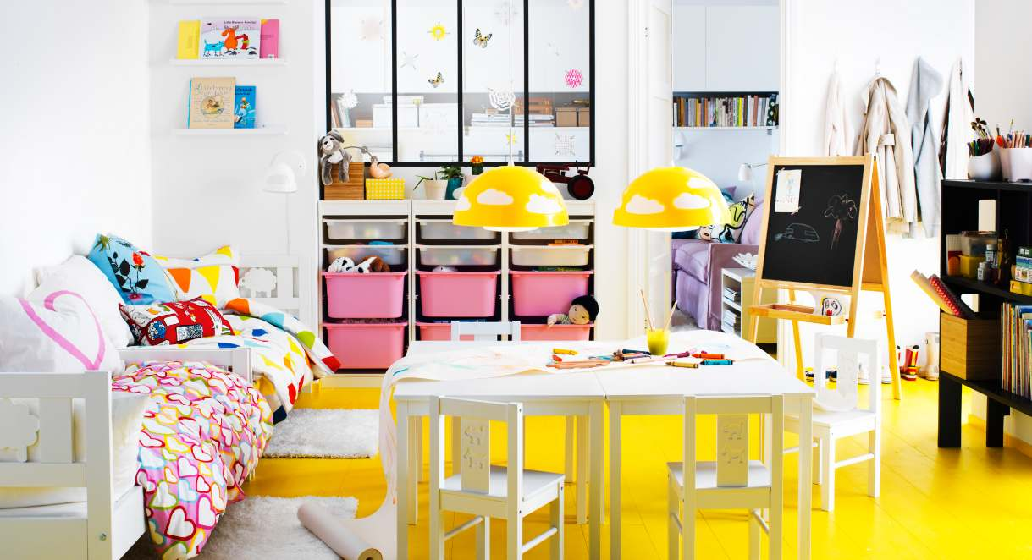
___________________________________________________________________________________________________________________________________________________________________________________________________________________________________________________________________________________________________________________________________________________________________________________________________________________________________________________________________________________________________________________________________________________________________________________________________________________

Speaking!
How can I get to?
Choose one of the places and tell how to get there from school. Think about the route and means of transport you have to use for it. Put down the details of your route.

library theatre cinema your house/apartment park circus

Ex.; You go out from school than you turn left. You go along Kozatska Str. till Bakery. Than you turn right and cross the road…
_________________________________________________________________________________________________________________________________________________________________________________________________________________________________________________________________________________________________________________________________________________________________________________________________________________________________________

Grammar!
Exercise 1
Fill in the gaps with the comparative degree

1) This cat is ______ than that monkey. (big)
2) This dog is ______ than that cat. (funny)
3) This woman is ______ than that woman. (beautiful)
4) This film is ______ than that film. (good)
5) This tomato is ______ than that tomato. (tasty)
6) Plane travel is ______ than car travel (fast)
7) The Thames is ______ than the Desna (long)
8) Buses are ______ in London than in Barcelona (expensive)
9) Trucks are ______ in the USA than in the UK (big)
10) Physicists are ______ than Biologists (smart)

Exercise 1
Write the comparative and superlative degree of the adjective. Pay attention to the final vowels.

simple ______________________________
happy ______________________________
low ______________________________
cheap ______________________________
big ______________________________
beautiful ____________________________
green ______________________________
deep ______________________________

lazy _____________________________
old ______________________________
serious __________________________
smart ____________________________
little _____________________________
bad ______________________________
narrow ____________________________
good ______________________________

Exercise 1
Translate the sentences using the appropriate form of adjectives.
- Мій брат – найвищий хлопець в класі.
- Нью-Йорк більший за Лондон.
- Амазонка – найдовша річка в Північній Америці.
- Восени повітря стає холоднішим.
- Моя мама розумніша за мою старшу сестру, але моя сестра – вищу ніж моя мама.
- Індійський слон менший за африканського слона.
- Найкрасивіше місце в Україні – Карпатські гори.
- Математика простіша за фізику, але фізика складніша ніж українська мова.
- Немовлята завжди щасливіші за школярів,тому що не мають ходити до школи.
- Чорне море – більше та глибше за Азовське.

