Reading!

Discuss
- Who would you like to become in future?
- What unusual job you’ve heard about?
- Would you like to have unusual job?

Read the text and write A if the sentence is true for Alan Watt, J if it is true for Jenny Howard or B if it is true for Both.
1. This person eats a lot of sweets.
2. This person travels to exciting places.
3. This person likes his/her job.
4. This person doesn't have time to relax.
5. This person has to exercise regularly.

Would you like to do this job?
Alan Watt, 42, lives in New York and works for World Traveller Tours.
His job is to find out about new holiday destinations. He usually flies to exotic places like Asia and the Caribbean, stays at beautiful hotels and eats at the world’s best restaurants. Doesn’t this sound like a dream job?
‘Well, it isn’t the high life you imagine,’ he says. ‘Typically, I step off the plane after a long flight and go straight into a business meeting. I have to check out hotels and restaurants and write reports. My schedule is so busy that sometimes I have hardly any time left to swim in the pool!’
Mr Watt spends about 120 days a year away from his family, but he likes his job because he always gets to see new, exciting places. Where would he like to go on holiday this summer? ‘Anywhere in New York,’ he laughs.
Jenny Howard, 25, gets paid to eat chocolate! She lives in Melbourne and works as a chocolate taster for Cadbury’s Australia.
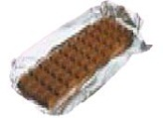
‘My job is to check that the products have the right taste and look good before we sell them,’she says. ‘I’m lucky, because I love sweets and I get to try all the new ones before anybody else in the world!’ But doesn’t chocolate make you fat? ‘Well, I don’t have to eat all the chocolates that I taste!’ says Jenny. ‘On a busy day I will try about 10 pounds of chocolate. I’d be sick if I ate it all! Nevertheless, I put on eight pounds in my first two months on the job! So I started going to the gym regularly, even though I don’t like exercising!’

- Read the text again and complete the questionnaires about Alan Watt and Jenny Howard.

1. What’s your name?....................................
2. How old are you?.......................................
3. Where do you live?....................................
4. Which company do you work for?.............
5. What exactly do you do?............................
6. What do you like most about your job?.....
7. What don't you like about your job?..........

1. What’s your name?....................................
2. How old are you?.......................................
3. Where do you live?....................................
4. Which company do you work for?.............
5. What exactly do you do?............................
6. What do you like most about your job?.....
7. What don't you like about your job?..........

Test your grammar!

Exercise 1.

Write the Past Participle of the following verbs.

be _________

build_________

give_________

go _________

throw_________

keep_________

sting_________

tell_________

think_________

understand_________

read_________

leave_________

draw_________

get_________

begin_________

fall_________

swell_________

shine_________

drive_________

hear_________

Exercise 2

Write the missing forms of the sentences.
- + He has eaten snake in China
- ____________________________________

? ____________________________________

- + ____________________________________
- She has never been to jungles.

? ____________________________________
- + ____________________________________

- ____________________________________

? Have you ever put a tent yourself?

Exercise 3

Open the brackets using Past Simple or Present Perfect
- From 2005 to 2010 Kate _____ (to attend) music school.
- When she was an administrator, she _____ (to work) ten hours a day.
- Where _____ all the teachers _____ (to go)?
- I _____ (to study) English since 2003.
- Last year Kate and July _____ (to travel) around the world together.
- They _____ (to study) Spanish at school.
- He _____ (to go out) four hours ago and _____ (not to return).
- How many pages _____ you _____ (to read)?
- What present _____ he _____ (to get) for his last birthday?
- I _____ (to go) home at 9 o’clock yesterday.

Exercise 4

Translate the following sentences using Present Perfect and Past Simple Tenses.
- Вчора я загубив мої ключі і тому зателефонував батькам, коли прийшов додому.
- Цього року я був в Парижі тричі, а минулого - двічі.
- Нарешті я склав всі екзамени! Ура!
- Вона живе з батьками вже 10 років.
- Ти коли-небудь був в Китаї?
- Я ніколи не куштувала паелью до сьогодні.
- Я загубила книгу. Можеш допомогти знайти її?
- Мій брат прочитав всі книги про Гаррі Поттера за тиждень, а я читаю третю книгу вже 4 дні.
- Весь минулий рік моя викладач ставила мені погані оцінки але в цьому році я працюю більше і мої оцінки набагато кращі.
- Мій вчитель сказав, щоу нас буде контрольна, тому я вчився вчора весь вечір.

Speaking!
Asking

Use prompts below and prepare list of questions using Present Perfect.
Answering

Make two circles. Students inside stand still and answer the

questions of students outside.

Student change the partner every time Teacher gives a signal.

After finishing students need to present the results and compare those.

swim in the ocean | visit the USA
be seasick | eat snake
be to a circus | sing karaoke
stay up the whole night | eat goat’s cheese
fail a test or an exam | break a bone
take selfie at school | see a shark

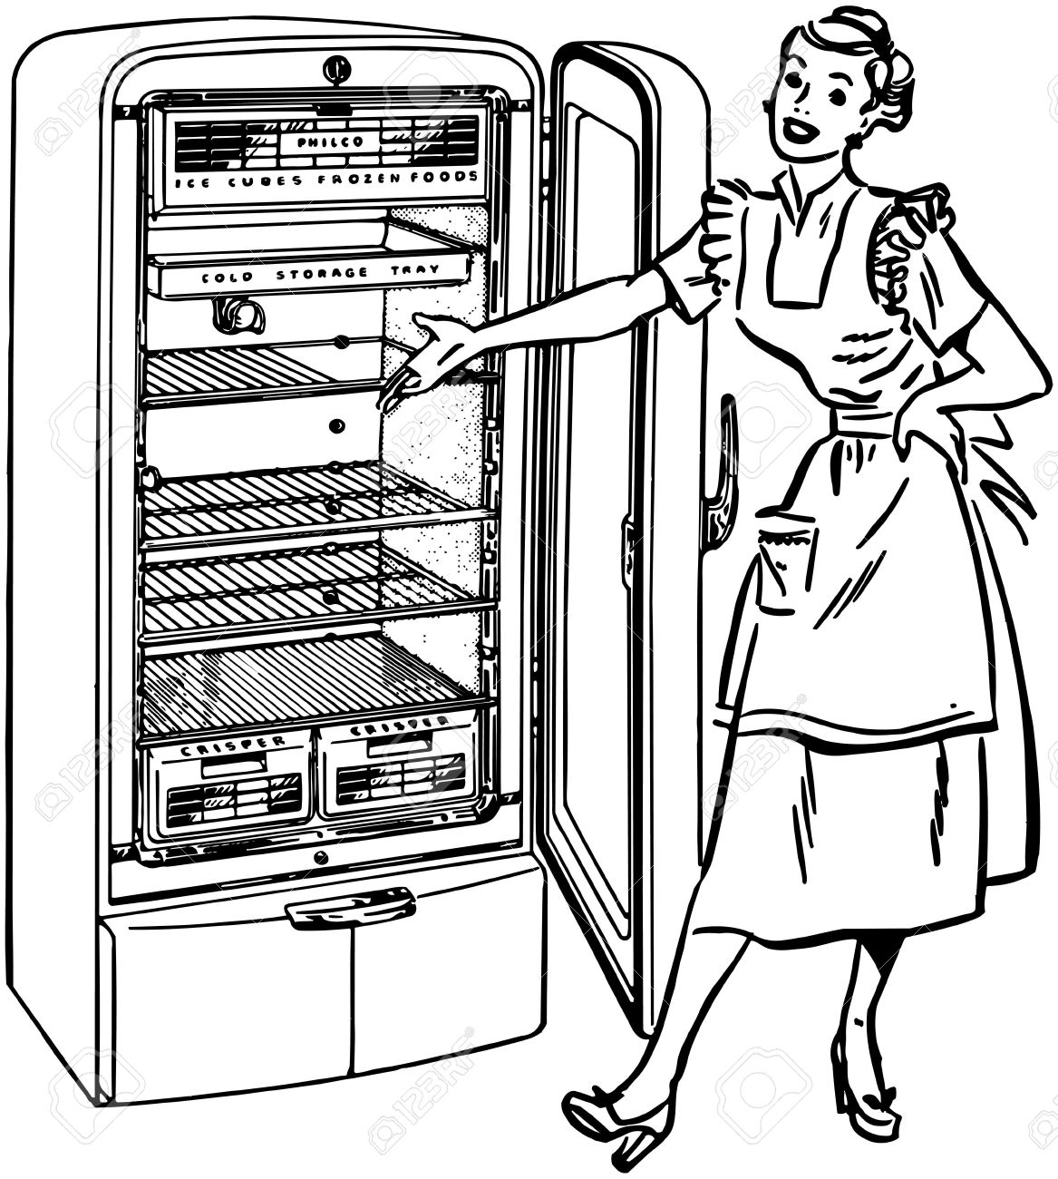

Speaking!
My fridge!

Make the list of products which you usually have in your fridge
E.g.: eggs, bread, milk....
Split them into two categories: healthy and unhealthy food.
What do you have more?
What products you would like to add to your fridge?
Make a poster and present it to your classmates.

Vocabulary!

Match the name of musical instrument with its picture.
Trombone Trumpet Keyboard Drums Piano Bass Acoustic guitar Percussions Electric guitar Violin Flute Harp

- 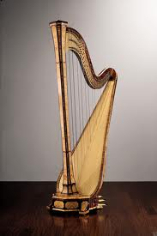b) 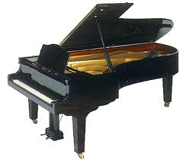c) 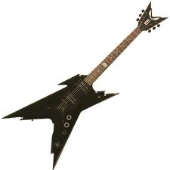d) 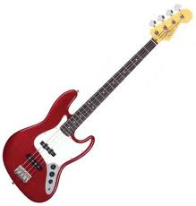e) e)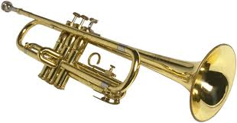 f)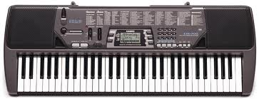
g)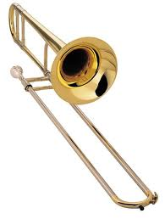h)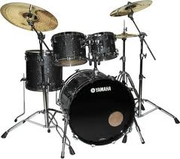i)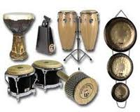j)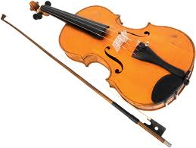
k)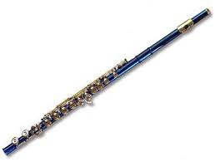

Answer the questions:
- Can you play any of the instruments? Explain how to play it.
- Choose one of the instruments and mime playing it to your classmates. The student who guesses the most instruments – wins.

My music band!

Discuss
- What is your favorite style of music?
- What is typical for this style: instruments, costumes.
- How many people are there in the musical band?

Split into groups of four and create your own band.

Think about:
- name
- style
- your listeners
- where you perform

Reading & Writing!

You read Dr Jennings’ forum and come across a post by Mr. Howard. Read the post and decide if the statements 1-6 are True or False. Write T for True or F for False in the boxes.

1. John has a bad cough.
2. John takes medicine.
3. John has a lot of stress at work.
4. John takes vitamins and eats healthy food.
5. John has a temperature.
6. John hasn’t been to the doctor lately.

Dr Jennings,
I have been ill lately and I’d like your advice on what I can do.
I’ve had headaches almost every day for two weeks. I keep taking painkillers, and they help for a little while, but the headache always comes back. I have never had heachaches like these before. A few days ago, I started having bad stomachaches, too.
I haven’t introduced anything new to my diet, I still eat the same type of food as before, so I don’t know what could cause them.
I am really stressed at work right now and I also work long hours. Could this have anything to do with the headaches and stomachaches? I take vitamins and eat healthy foods, but I don’t exercise much. I don’t really have time, because it seems that I’m always on the go. I never get a chance to calm down and just relax. I know that too much stress is bad, but can stress give you health problems like this? If it’s not stress, what else could it be? I don’t usually get sick very often, I don’t even remember the last time I had a temperature, for example. It’s been a while since I last went to the doctor for a check-up, so maybe something is wrong with me. Please let me know what you think, and what I can do to feel better.
Thanks very much,
John Howard

Writing
Reply to John’s post and give him recommendation how to get rid of that state. Remember that you are writing on the forum, so consider the following issues:
- greeting
- contractions
- sentence structure
- sentences style

Write a reply 100-150 words.
____________________________________________________________________________________________________________________________________________________________________________________________________________________________________________________________________________________________________________________________________________________________________________________________________________________________________________________________________________________________________________________________________________________________________________________________________________________________________________________________________________________________________________________________________________________________________________________________________________________________________________________________________________________________________________________________________________________________________________________________________________________________________________________________________________________________________________________________________________________________________________________________________________________________________________________________________________________________________________________________________________________________________________________________________________________________________________________________________________________________________
Reading!
Discuss
Have you ever been a volunteer?
Why do people work for free? What are the benefits of such work?

Read the text and answer the following questions. Write M for Mark, S for Sue or E for Eileen in the boxes.

Which volunteer saw the Olympics as:
1. a chance for his/her dream to come true?
2. an opportunity to offer his/her professional skills?
3. an opportunity to work with people from different countries?
4. a good way to continue his/her volunteer work?
5. a chance to make friends?

Thousands of people work hard without pay at each Olympic Games. Without these volunteers, the Olympics as we know them today would not take place. Together with the athletes they make the Games possible. But what makes so many people offer their free time to the Games? Mark, Sue, and Eileen have all chosen to be volunteers in past events. Let's find out why.
Mark saw the Games as a great opportunity to take part in the world's biggest sporting event. ‘I watched the Olympics on television many times and I always dreamt of taking part,’ said Mark. When the Games took place in his hometown, Mark got the opportunity to make his dream come true. Mark considers his time as a volunteer to be the best experience of his life.
Sue took part in the Opening Ceremony of the Olympics. ‘I was really excited when I found out that half of the world's population would watch it.’ Sue saw her volunteer work as a once-in-a-lifetime experience. She went on to say that she made many friends and enjoyed working with talented people from all over the world.
Eileen always volunteers for community events. So for her, volunteering for the Olympics was a natural thing to do. Also, being a bus driver, Eileen thought it would be a good idea to move athletes around from the Olympic Village to the stadiums. She described her time as a volunteer as ‘unforgettable and exciting.’

Project!
Olympic village

An Olympic Village is an accommodation center built for the Olympic Games, usually within an Olympic Park or elsewhere in a host city. Olympic Villages are built to house all participating athletes, as well as officials and athletic trainers.

Work in teams of three or four. Imagine you are one of the organizers of Olympic Village.
Make a poster of your Olympic Village and include the following information:
- location
- accommodation
- food
- entertainment
- sport places

Present your project to you classmates and vote for the best one. You cannot vote for your team.

Grammar!
Exercise 1
Open the brackets using Present Simple Passive.
- What drink (to drink) mostly in Ukraine in summer?
- What marks (to get) usually when a student is not ready for the lesson?
- Where (to watch) usually the new movies?
- What subjects (to teach) at school?
- What (to sell) in school canteen?
- What clothes (to wear) usually when it's cold outside?
- What (to eat) usually in Ukraine for breakfast?
- How often (to organize) concerts in your school?
Discuss the questions with your partner.
Change the sentences into Past Simple Passive.

Exercise 2
Translate the following sentences using the Present or Past Simple Passive.
- Хтось загубив мого листа вчора.
- Я читаю одну нову книгу кожного місяця.
- Моя бабуся прибрала всі кімнати.
- Навесні ми з мамою саджаємо квіти у нашому саду.
- Колумб відкрив Америку.
- Хтось з’їв всі пиріжки.
- Я роблю домашнє завдання кожного вечора.
- Цей будинок побудував мій дід, а бабуся - пофарбувала, а ми батьками кожного року робимо генеральне прибирання.

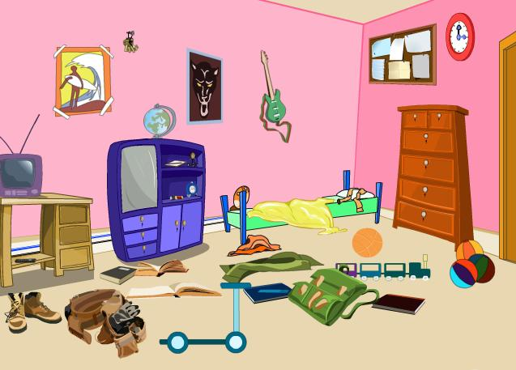
It was not me!
Work in pairs. Student 1 of you is a mother who comes home and sees her house in a mess.
Student 2 is a child. Your mother thinks that you did it all, but you know it was your younger brother.
Make u s a dialogue to illustrate the situation.
Use Past Simple Active or passive.
E.g.
M.: Why did you leave your shoes in the living room? It was done not for the first time!
C.: Sorry Mum, I didn’tdo it. The shoes were left by Andrew! e.t.c.

Present you dialogues to the class.

Reading!

Discuss
- Look at the pictures. Where is Chamonix? What activities can you do there?
- Read the text and check your answers.

Welcome to Chamonix

The resort of Chamonix in France is a great place for a family holiday because there is something for everyone. The Chamonix valley lies in France between Servoz and Barberine on the Swiss border. Chamonix is one of the towns in the valley. The valley includes spectacular mountain scenery including Mont Blanc, the highest mountain in Western Europe.
Chamonix is perfect to visit any time of the year. For example, in the winter you can enjoy skiing around the Mont Blanc area. For those new to skiing there are numerous ski schools. For the more adventurous there are difficult ski slopes. If you want to explore the snowy mountains, you can go snowshoeing – that is, walking on deep snow wearing special shoes. This is a great way for young and old people to take a closer look at the beautiful scenery.
In the summer, visitors can choose from many different things to do. For example, you can go hiking, walking, climbing, paragliding, mountain biking and do various water sports. There are also kids clubs and adventure camps. They offer a variety of fun activities for both younger children and teenagers. There are also interesting cultural events and shows.
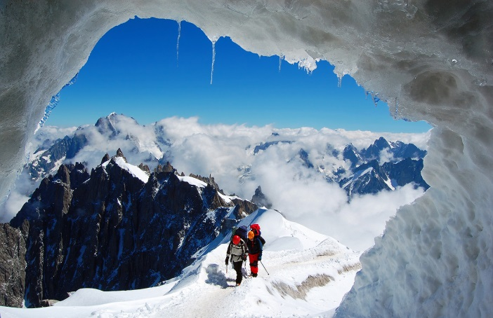
The town of Chamonix has some beautiful and historic buildings, too. There are museums and galleries, shops, cafés and restaurants. Chamonix is a fantastic place to go if you enjoy the outdoors and you want a fun holiday. It can help you relax and keep the kids very happy.
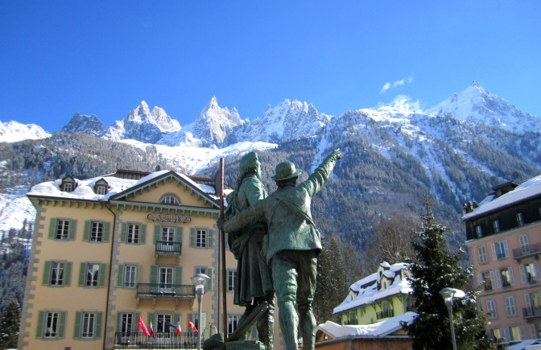

Read the text again and write T for True, F for False or NM for Not Mentioned.
1. Chamonix is close to the Swiss border.
2. You need to be an experienced skier to ski in the Chamonix resort.
3. It is better to visit Chamonix in the summer.
4. There is nothing for teenagers to do in Chamonix.
5. You can see some very old buildings in Chamonix.

Project!

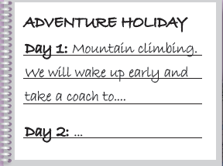
You are going out of the city with your friends.
Decide:
- where the holiday will be,
- how many days it will last
- which activities there will be.
Write a description for each day (like on the left) and present it to your classmates.

