Reading
Read the text and name each girl.
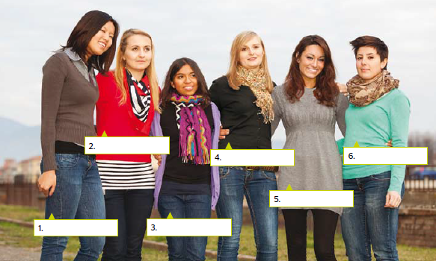

Do you want to see my sister and our friends? I have a picture of all of us together on my mobile phone. My sister, Anna, and I like to hang out with our friends in our free time. Why don’t you take a look?
See! My sister and I don’t look alike at all. She’s the one with the short brown hair. It’s funny but people think that my cousin, Sylvia, is my sister because we both have long blonde hair. I hate that because Sylvia and I are very different. She laughs all the time and thinks everything is funny but I’m serious and hardworking. She never wears bright clothes, but my closet is full of colours. My sister likes colours, too, so we borrow clothes from each other.
My best friend, Ava, is Chinese. She is kind and friendly. We always stand next to each other in photos. The girl with the long wavy brown hair is Natasha. Doesn’t she look fashionable in this photo?
Tania is the short girl. Do you know her? She’s a tennis champion. Our names are the same but she spells hers with an ‘i’ and I spell my name with a ‘y.’ Our friends call us tall Tanya and short Tania. We don’t mind.

Read the text again and match the sentences

1. Ava
2. Anna and Tania
3. Ava and Tanya
4. Sylvia and Anna
5. Tania
6. Anna and Tanya
a. are friends.
b. are cousins.
c. are sisters.
d. is from China.
e. is a famous tennis player.
f. are best friends.

How does your friend look like? Describe him/her using 5-8 sentences. Pay attention to: appearance, behavior, traits of character.
______________________________________________________________________________________________________________________________________________________________________________________________________________________________________________________________________________________________________________________________________________________________________________________________________________________________________________________________________________________________________________________________
Grammar!
STATIVE VERBS

Stative verbs are verbs that cannot be used in any of the Progressive tenses.
Verbs having * can be used in Progressive tenses, depending on meaning of the verb.

Be *  Believe  Belong  Enjoy  Forget  Have* | Hate  Hear  Know  Like  Look  Love | Need  Notice  Prefer  Realize  Recognize  Remember | See*  Surprise  Taste*  Think*  Understand  Want

* Be → constant state → Simple
↘ present time condition → Progressive

Have → possess → Simple
↘ part of a fixed phrase (have fun/ breakfast/ lunch) Progressive

See → eye perception → Simple
↘ Having an arrangement, dating → Progressive

Taste → have a characteristic → Simple
↘ try → Progressive

Think → have an opinion → Simple
↘ consider → Progressive

Exersise 1

Fill in the sentences with the correct form of the verbs in brackets. Use the Present Simple or the Present Continuous. Pay attention to Stative verbs.
- I ……………………….. (hate) whan people chat on the phone in public transport.
- I …………………………(know) who is spreading the gossip.
- She …………………………… (think) that her parents will yell when they find out the result.
- The mobile …………………………………… (belong) to the teacher.
- She …………………………………… (understand) why Caroline ............... (whisper). She (want) ............ to tell the secret.
- I …………………………………. (not/believe) gossips.
- I …………………………(think) you should be more hardworking.
- Ron and Mary ……………………(see) each other now and they are always chatting on the phone.
- He ……………………. (believe) that his friend ………………………… (be) completely wrong.
- I am so tired nowadays so I ……………………… (need) a vacation.

Exersise 2
Fill in the sentences with the correct form of the verbs in brackets. Use the Present Simple or the Present Progressive. Pay attention to Stative verbs.

Students of St. George School always (prepare) __________ a play for Christmas. Teachers of school (take part) _________ in the setting as well. Today (be) _____ the day of staging. Actors (prepare)_______ their costumes and (finish) _______ their make-up. Many student have never been on stage so they (try) ____ to calm themselves down. They (not know)_______ what (happen)_______ in the hall. All participants (hope) _______ to perform well and that their guests will like the play.
When the play starts all actors can see the everybody (listen) ________ and nobody (talk)____________ on the phone or (chat)__________ with the person next seat. Actors (feel) ________ relieved and (want)___________ to do everything perfectly.
After finishing the play they (be) ______ extremely happy and (look forward) ______
To the next year!

Exersise 3
Make up the questions using the words given. Use ‘used to’. If not possible – use ‘past simple’.
Write a positive and negative answer
- Get up/ late / be / child? ___________________________________________________________________
___________________________________________________________________
___________________________________________________________________
- Love / watch/ cartoons / be/ child? ___________________________________________________________________
___________________________________________________________________
___________________________________________________________________
- Eat / porridge / be/ child?
___________________________________________________________________
___________________________________________________________________
___________________________________________________________________
- Visit / Disneyland / be/ child?
___________________________________________________________________
___________________________________________________________________
___________________________________________________________________
- Read / Harry Potter/ be/ child?
___________________________________________________________________
___________________________________________________________________
___________________________________________________________________
- Believe / Monster under bed / be/ child?
___________________________________________________________________
___________________________________________________________________
___________________________________________________________________
- Sleep/ until noon/ be / child?
___________________________________________________________________
___________________________________________________________________
___________________________________________________________________
- Dream / become / rock-star / be / child? ___________________________________________________________________
___________________________________________________________________
___________________________________________________________________
- Study / foreign language / be / child? ___________________________________________________________________
___________________________________________________________________
___________________________________________________________________
- Dream / have / superpower? ___________________________________________________________________
___________________________________________________________________
___________________________________________________________________

Use the questions 1-10 to interview your classmates and present information about one of them to the class.

Student 1  Name | Student 2  Name | Student 3  Name | Student 4  Name | Student 5  Name
1._____________  2. ____________  3. ____________  4. ____________  5. ____________  6. ____________  7. ____________  8. ____________  9. ____________  10. ___________ | 1. ___________  2. ___________  3. ___________  4. ___________  5. ___________  6. ___________  7. ___________  8. ___________  9. ___________  10. __________ | 1. ___________  2. ___________  3. ___________  4. ___________  5. ___________  6. ___________  7. ___________  8. ___________  9. ___________  10. __________ | 1. ___________  2. ___________  3. ___________  4. ___________  5. ___________  6. ___________  7. ___________  8. ___________  9. ___________  10. __________ | 1. ___________  2. ___________  3. ___________  4. ___________  5. ___________  6. ___________  7. ___________  8. ___________  9. ___________  10. __________

Speaking!
Student A: you are a participant of a student exchange programme and moving to another city in your country for 3 month. Ask student B about the most exciting places to visit.

Student B: Student A is moving to your city. Help student A decide on the most interesting places to visit.

Include the information about:
- Weather conditions
- Local cuisine (restaurants, cafes etc.)
- Local animal world
- The most touristic places

Useful phrases:
Typical weather situation in this time of the year is…
You might find interesting…
This is the place where…
You might want to see/visit…
The most famous/popular/well-known dish/drink is…
It is usually cooked/served
One of the advantages/attractions of …is …
The numerous animal inhabitants of this territory …
Another advantage/disadvantage of this area is…
If you don’t mind …, you could…

Speaking!

Look at the pictures and comment on where you would like to spend your weekend.
Make a list of reasons why you would like to go there.
1.___________________________________________________________________________
2.___________________________________________________________________________
3.___________________________________________________________________________
4.___________________________________________________________________________
5.___________________________________________________________________________

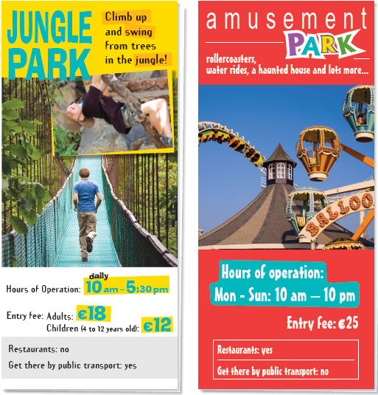

Discuss this question with your partner. Prepare the dialogue and present it to the class.

Grammar!

Exercise 1
Open the brackets using the Present Perfect Simple, Present Perfect Progressive or Past Simple of the verbs.
(1) _______ you_______ (ever/hear) of anyone getting paid to stay in bed for up to two months? Too good to be true? Well, it is! A team of space scientists (2) ______(want) to investigate the changes that take place in the human body during long space journeys so they (3)_______ (start) carrying out a series of experiments a few months ago. They (4) (put) advertisements in several newspapers for volunteers who were willing to spend 60 days in bed. They were expected to eat, drink, watch TV and even have a shower while lying down! Dr Vladimir Tursunov, one of the scientists that (5) (be) involved in the project since it (6)______ (start), said: ‘Thousands of
people (7)________ (apply) when they (8) ________ (see) the advertisement in the paper. It (9)________ (be) really difficult to decide which ten would be the most suitable. The participants (10)___________ (already/be) exhausted because of all the intense medical examinations. Now, however, they have all the time in the world to relax...’ . Alfred, one of the participants in the programme, (11)_______ (lie) in bed for 32 days. ‘At first I (12)______ (find) it hard, but now I (13) ________(become) quite used to it. Plus, the money is really good; how many people do you know who earn €4500 in just two months’? Sometimes it pays to sleep on the job!

Exercise 2
Open the brackets using Past Simple or Present Perfect.
- 'This is my house.' 'How long have you lived here?' 'I _______ (live) here since 1997.'
- He lived in London for two years and then he (go) to Edinburgh.
- When I left school, I cut my hair and (wear) it short ever since.
- Shakespeare (write) a lot of plays.
- My brother (write) several plays. He has just finished his latest.
- I (not see) him for three years. I wonder where he is.
- He (not smoke) for two weeks. He is trying to give it up.
- Chopin (compose) some of his music in Majorca.
- 'When (he/arrive)?' 'He arrived at 2 o'clock.'
- I read his books when I was at school. I (enjoy) them very much.
- I can't go out because I (not finish) my work yet.
- 'I (never/drink) whiskey.' 'Well, have some now!'
- Here are your shoes. I (just/clean) them.
- I left home at 8.00a.m. and I (get) here at 12.00p.m.
- I (meet) him last June.
- (you/see) the moon last night?
- Cervantes (write) Don Quixote.
- He (break) his leg in a skiing accident last year.
- 19. Jim: How many times (you/try) to pass your driving test?
Michael: Three times so far.
- When (you/go) to Rome?
- You look different. (you/have) a haircut?
- I (not/see) David at all this week. I don't even know where he is.
- Jim: (you/speak) to Peter yet?
Michael: No, not yet.
- When (you/start) your job?
- I (move) house three times in the last five years.
- My sister (be) to New York three times and she's going again next month.
- The US President (be) in our country last year.
- The US President (visit) our country three times in the last two

Reading!

Discuss
- What is phobia?
- What kinds of phobias do you know?
- Do you know the meaning of the following?

Match the name of the phobias to its meaning
Arachnephobia Bacteriophobia Obesophobia

- fear of putting on weight
- fear of spiders
- fear of bacteria

Read the texts and write C for Carrie, J for John, D for Daniel, or N for none in the sentences below.
1. My phobia is food-related.
2. I’ve visited a therapist to help me deal with my phobia.
3. My phobia influences what I wear.
4. My phobia made me feel very uncomfortable once.
5. I have tried to cure my phobia.
6. I’ve had a couple of accidents because of my phobia.

Strange phobias!

We asked and you responded: tell us your strangest phobias!
We know a lot of people are afraid of heights or closed spaces, but what are some really weird things to be afraid of?

Carrie – Selachophobia
Ever since I was little I have been afraid of sharks. I know that a lot of people are afraid of sharks, and that’s not a strange phobia, but I am actually just afraid of pictures of sharks. I can’t open a National Geographic or any other
wildlife magazine without getting nervous. It’s even worse when the shark has its mouth open in the picture. I feel like the shark can still bite me. One time, while I was reading a magazine in the library, I turned the page and there was a big picture of a shark! The worst part is that when my hand turned the page, my fingers were actually touching the picture.
I screamed and threw the magazine across the room. Everybody laughed and I was really embarrassed. Oddly enough, sharks in aquariums or zoos don’t bother me at all.

John - Koumpounophobia
I am absolutely terrified of buttons. I don’t mind wooden buttons or something like that, it’s the plastic ones I can’t stand.
Unfortunately, most of the buttons out there are made of plastic. I can’t look at them, I hate touching them, I don’t even like talking about them! Most people think it’s really hard to live without buttons, but it’s actually not. I dress quite casually anyway, so I just wear T-shirts and stuff. It used to really upset me as a child, watching my grandma sew a button on a shirt. She would always hold it in her mouth, as she was getting ready to sew it on. That used to drive me crazy! I thought it was the most disgusting thing in the world! The worst is when I see a button that has a little bit of the thread that’s loose and hanging down. That makes me want to run out of the room!

Daniel - Oneirophobia
Have you ever known anyone who was afraid to go to sleep?
Well, now you have! That’s a little misleading though, as I’m not actually afraid of sleeping, I’m afraid of dreaming. It’s not like I’m afraid of nightmares or something, I just don’t like the idea of dreaming at all. It feels like you completely lose control of your own mind when you’re dreaming, and I don’t like that, even if it’s a good dream. Usually, when I go to bed and I feel myself starting to fall asleep, I get a panic attack, and my heart starts racing. Sometimes I even
feel like I will be sick! It is a serious problem, because it’s very unhealthy to go without sleep.
I’ve tried everything to make myself really tired when I try to sleep, drinking warm milk, herbal sleeping aids, even therapy! A friend suggested hypnotherapy, so I think I will try that. I really do want to sleep, it’s just impossible.

Grammar!

Exercise 1
Complete the following sentences with a suitable question tag.
- That’s nonsense, ___________________?
- You are superstitions, ___________________?
- Friday the 13th is a usual day, ___________________?
- Walking under the ladder brings bad luck, ________________________?
- He looked really scared when he broke the mirror ________________________?
- You can avoid bad luck, ________________________?
- It happened thank to a four-leaf clover, ____________________?
- My grandmother has never had a black cat, _______________________ ?
- She will get rid of the broken mirror, ______________________?
- Stop worrying about your horseshoe! We’ll find it, _________________________?
- You aren’t superstitious, ____________________?
- You don’t have lucky socks, _____________________?
- You weren’t able to win because of bad luck, _____________________?
- He wasn’t happy when he found a broken horseshoe, _____________________?
- Mary cannot stay at home on Friday, the 13th, _____________________?
- I have never had a black cat, ________________________?
- You won’t walk under the ladder, _____________________?
- Jill didn’t want to scare your cat, ____________________?
- Helen is going to buy a new mirror, ____________________?
- Your uncle has found a four-leaf clover, ________________________?

Exercise 2
Read the situations below and write sentences with question tags.

- You think that your friend's brother is very clever. What do you say to your friend?
_______________________________________________________________________
- You think that Beyoncé sings very well. What do you say to your friend?
_______________________________________________________________________
- You went to a concert with your friend yesterday and you think it was fantastic. What do you say to your friend?
__________________________________________________________________________
- You and your friend want to make a cake but you believe that there aren't enough eggs. What do you say to your friend?
_______________________________________________________________________
- You are not sure if your dad has fed the cat. What do you say to your mum?
_______________________________________________________________________
- You believe that the students at your friend's school recycle paper but you are not sure. What do you say to your friend?
__________________________________________________________________________
- You want to go to the theatre with your friend. What do you say to your friend?
_______________________________________________________________________

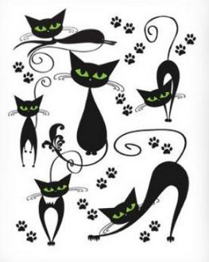
Speaking!
Discuss
- Are you a superstitious person?
- Do you know any people who believe in superstitions?
- How do superstitions appear? Is it likely to stop believing in them?
- Do you know any of superstitions below? Do they bring good or bad luck?

Dove knocks at your window | Bee enters your home | To wear red string on the left hand | Four-leaf clover
To meet an old woman with empty buckets | To see three butterflies together | To walk on a crack in the pavement | To whistle indoors
Rabbit’s foot | To open an umbrella indoors | To pull out a loose eyelash | To trip over your left foot
To walk under the rainbow | Your right hand itches | To spill salt | To find a sea shell with a hole

Grammar!
Exersise 1
Fill in the sentences with the Past Simple or Past Perfect of the verbs in brackets.
- My was robbed last year. She __________ (never / be) robbed before that.
- We didn’t need to wait long because my wife __________ (already / call) the police
- The thieves had already spent the money when the police _________ (catch) them.
- Police ________ (know) her address because she _______ (tell) them.
- The juvenile delinquency _________ (be) a big problem before WWII ___________ (begin).
- Everyone ___________ (witness) that the blond woman __________ (pickpocket) the granny.
- She ________(want) to go to the court because she ___________ (never / see) the trial.
- My niece _________ (go) to prison last week because she _________ (aim) to become a policewoman.
- After arsonists _________ (set fire) in the park, police ___________ (arrive) and __________ (arrest).
- Kidnapping ________ (happen) five days ago and kidnappers still _________ (not / call)to ask for reward.

Exercise 2
What had happened?
Read the situation and offer several options of what had happened and caused the following situation. Provide 3-4 statements for each issue.
You came home from work and saw:
- new door handle
- cat sitting on the sofa (you have no cat)
- missing pictures on the walls
- room with different furniture
- walls painted in different color

E.g.: When I came home I saw a new door handle. My father had changed it while I was at work.

Create your own crime story!
Split into four groups Use the words given and create your own crime mystery. You should use all the words and begin the story with sentence given.
Captain Smith was walking home after his training and dreaming about a nice evening with his wife. When turned the corner on the Fifth Street he felt…  Key words: beggar, McDonald’s, schoolchildren, car, kidnap, roses. | When Alex was going home form gym he suddenly noticed that…  Key words: car, woman, shoplift, money, red coat, flowers.
Everything happened on Monday morning. Jill was, as usual, driving her children to school when she remembered…  Key words: house, flat tire, policeman, bookstore, burglary, pink. | One rainy morning Carol went out from the office to get some coffee…..  Key words: man, bus stop, lightning, child, dream, arrest.
Present your case to the classmates. They can ask you six questions (two for each group).
Can they work out the criminal?
Notes

_____________________________________________________________________________
_____________________________________________________________________________
_____________________________________________________________________________
_____________________________________________________________________________
_____________________________________________________________________________
_____________________________________________________________________________
_____________________________________________________________________________
_____________________________________________________________________________
_____________________________________________________________________________
_____________________________________________________________________________
_____________________________________________________________________________
_____________________________________________________________________________
_____________________________________________________________________________
_____________________________________________________________________________
Vocabulary!

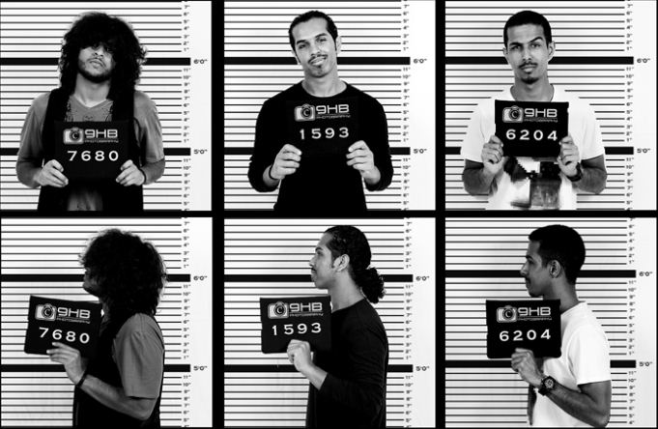
Exercise 1.
Fill in the table with the correct name of the criminal and the verb.
Crime | Criminal | Verb
Burglary
Fraud |  | -
Pickpocketing
Arson
Shoplifting
Bribery |  | -
Mugging
Vandalism
Blackmail
Kidnapping
Theft

Exercise 2
Match the crime to its description.
- Entering somebody's home and stealing his or her things
- Physically attacking somebody in the street and stealing from him or her.
- Provide false information in order to male other people believe you.
- Taking a person (often a child) and demanding money.
- Paying someone for favors, often a government official.
- Taking secretly away something that doesn’t belong you.
- Stealing money by taking it from other people’s pockets (one kind of “theft)
- Using fire to destroy something.
- Making someone pay you because you have a secret about them.
- Damaging or destroying property for no particular reason.
- Stealing things from a shop.

Discuss
What might be done in order to prevent crimes in the society?
Put down you ideas and discuss them with your desk mate.
___________________________________________________________________________________________________________________________________________________________________________________________________________________________________________________________________________________________________________________________________________________________________________________________________________________________________________________________________________________________________________________________________________________________________________________________________________________

Reading!

Read the text and decide if the statements are True, False or Not Mentioned. Write T for True, F for False or NM for Not Mentioned in the boxes.

The Time Machine

The Time Machine was first published in 1895 and sold more than six thousand copies in a few months. H.G. Wells was just 27 when the story was published.
The novel was very popular because Wells presents an interesting view of what he believes will become of human beings in the future. The central character of his story is a time traveler who goes back and forth in time with the help of a machine he invented. The story begins in his home in London, where he explains his experiment to his friends and shows them how time travel is possible with a small time machine. Then, he creates a larger version of the machine that can carry himself.
His first stop is 802,701CE where the world is populated with human-like creatures called Eloi. He believes that humans have developed into the Eloi, who seem to live a happy and peaceful life. In actual fact, the world is ruled by the Morlocks, a different kind of wild, human-like creature which lives underground. It becomes clear that the Eloiare just there so that the Morlocks can feed on them.
The time traveller becomes friends with an Eloi called Meena after he saves her life. Later, his time machine disappears, and at first he believes that the Eloi moved it somewhere else. Then he realises that the Morlocks have taken it and he is forced to go underground and get it. After fighting with the Morlocks, he manages to find the time machine and get it working. He travels 35 million years into the future where he finds a dark world with few living creatures. The Earth has stopped turning and the Sun is a blood red colour. Just as he is about to leave for the present, he sees a huge monster coming out of the sea. Luckily, he manages to escape just in time.
He reaches home exhausted where he tells his friends about his adventures. Most of them don’t believe a word he says. In the end, he takes a backpack and a camera and tries to travel through time again, but he never returns.

1. The Time Machine was H.G. Wells’ first novel.
2. The time traveller uses a model to show his friends that you can travel through time.
3. The Eloi are peaceful creatures who live underground.
4. The Morlocks steal the traveller’s time machine.
5. The time traveller finds no life on Earth when he travels 35 million years in the future.
6. The time traveller’s friends are too scared to join him on his second journey.

