Listening & Speaking

One-sided Conversation
Stage one
Take your mobile phone and pretend you are talking to someone. After you finish Students need to quess the topic of the conversation.
Stage two
You repeat your conversation and Students put down the missing phrases, appropriate by the context.
E.g.:
- Hello, can I speak to Sarah, please?
- ………
- Oh, I didn’t know about that. May I ask when she comes back?
- ………
- It’s Helen, her classmate. I wanted to give back her book.
- ………
- Thank you very much. I will call when she is back.
- ………
-Thank you. Good-bye!

Split Students into pairs and Ask them to act out a one-sided dialogue for each other.

Grammar
Exercise 1
Choose the word or phrase that is grammatically correct.
1. This chocolate cake is delicious! _____ I have another piece?
a. Need b. Could c. Might d. Must
2. I left my keys at home. They’re not in my bag.
a. must have b. can have c. would rather have d. need to have
3. You be back by 10 o’clock, otherwise we’ll be late for the meeting.
a. can b. may c. can’t d. must
4. Where’s Harry? He at home. I called and there’s no answer.
a. can’t be b. must be c. has to be d. needs to be
5. It’s raining again. You take your umbrella with you.
a. must b. don’t have to c. would rather d. need
6. You bring the books today. I don’t need them right away!
a. mustn’t b. have to c. needn’t d. don’t have
7. Julie put her coat on because it was very cold outside.
a. had to b. must c. might d. can’t
8. Stephanie studies hard. She be a very good student.
a. rather b. can’t c. doesn’t have to d. must
9. I have a glass of water, please?
a. May b. Might c. Can’t d. Need
10. She’s driving carelessly. She have an accident.
a. must b. could c. would rather d. need

Exercise 2
Underline the correct option: Gerund or Infinitive
- When I have my own house I am going to learn to play / playing the drums.
- My crazy dentist wanted taking out / to take out all of my teeth!
- It’s difficult to find / finding a good Chinese restaurant in Ukraine.
- I have left my purse in the office. Would you mind to lend / lending me money for coffee?
- When my parent were schoolchildren they decided getting / to get married.
- Would you like going / to go out with your friends at the weekend?
- My grandfather isn’t allowed drinking / to drink coffee because he has heart issues.
- If you cannot do this task, why don’t you try to move / moving to the next one?

Exercise 3
Open the brackets. Use the full infinitive, the bare infinitive or the -ing form of the verbs.
- Can you tell me what (do)? Can you (give) me some advice?
2. Your problem is serious. Let me (think) about it.
3. (play) football is a great way to keep fit.
4. You seem (be) ill. Why don’t you (make) an appointment with the doctor?
5. Alex suggested (go) to the cinema to see a comedy but I can’t stand (watch) comedies.
6. I went to school yesterday (see) my daughter’s teacher.
7. I managed (save) up money to buy a car.

Video

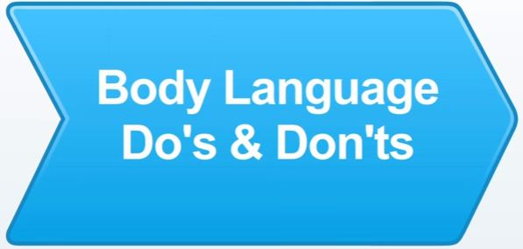

Discuss.
How do you understand this statement. Do you agree with it?

‘Your body speaks much more loudly than your words speak.’

Vocabulary
Make sure that the following words and phrases are familiar to you.

have a bit of truth
exhibit
positioned
seem
insecure
come across
have a hard time
folded
distract
give off an impression
speak a great deal
make sure

Video
Watch the video. Does the presenter agree with the statement? Why/Why not?
https://www.youtube.com/watch?v=ZlBQxCzgRLw

Watch the video again and answer the questions:
- What are the most important aspects of your body language?
- How can shoulder position affect a general impression of you?
- What are the ‘don’ts’ of your hands?
- Is being stationary a positive or negative sign of person’s body language? What does it say about?

What will it be like…?

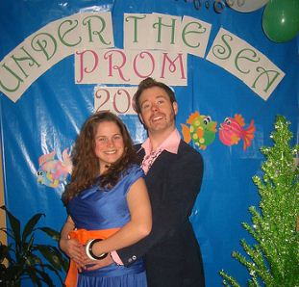
You need to use your mobile phones for this activity or Ss need to seat backs to each other.
Situation: You are one of the Prom co-organizers and you need to make clear the evening details. You are calling to another co-organizer but your battery is about to die and you have only two minutes in order to clarify the necessary information.
Make the list of question you consider to be important.
You may include the following topics:
- Venue
- Animation
- Dress-code
- Music
- Menu

After finishing the conversation present the results to your classmates.

Taboo!
Pick one card and explain the words given without mentioning taboo words.

MEMORY STICK  Taboo  DATA  USB  TRANSFER | MOUSE  Taboo  CLICK  HAND  MOVE | PRINTER  Taboo  PRINT  PAPER  DOCUMENT | LOUD SPEAKER  Taboo  SOUND  LISTEN  VIDEO
SOFTWARE  Taboo  PROGRAMMES  COMPUTER  ICON | MESSAGE  Taboo  CHAT  COMMUNICATE  TYPE | COMPUTER  VIRUS  Taboo  DAMAGE  PROGRAMME  DOWNLOAD | GADGET  Taboo  EQUIPMENT  COMMUNICATE  PORTABLE
MONITOR  Taboo  SCREEN  COMPUTER  DISPLAY | HARDWARE  Taboo  COMPUTER EQUIPMENT  SOFTWARE | SOFTWARE BUG  Taboo  ERROR  PROGRAMME  FAILURE | COMPUTER  Taboo  MACHINE INTERNET  PRINT

Speaking!

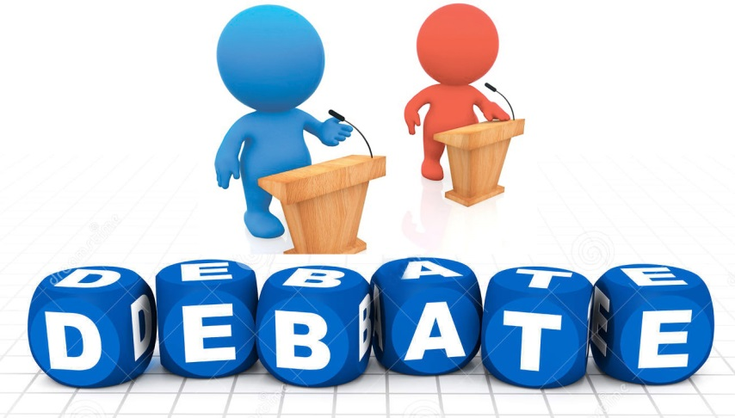

Think about the role of computers in modern life. It may be Negative and Positive as well.
Split into two teams and work out as many reasons to support your side.
You get one point for each reason.

Example:
For Computers have any programs, which make everyday life easier.
Against Computers make people lazy.

Grammar
Exercise 1.
Rewrite the sentences in the Passive Voice.

1. They showed her the easiest way to do it.
2. The lawyer have him the details of his uncle’s will..
3. The police are asking Mary many great questions.
4. Somebody told me the answer.
5. Why did they send her a present?.
6. When did they offer her a new job?
7. Somebody has lent me a record player.
8. They won’t promise John a bigger salary.
9. He made me do it.
10. Didn’t they tell you to be here at 6 o’clock?
11. They advised me not to buy the news
12. They didn’t pay him for the work.

Exercise 2.
Use the information below to make the sentences. Use Passive Voice
Lost dog
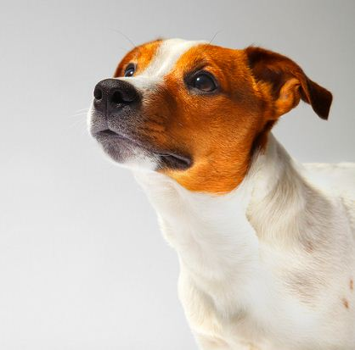
- A dog (named Kylie)/ lose/ park/ yesterday.
- Kylie/ lose/ before.
- Park / search / yesterday.
- Kylie / notice / in the park / yesterday.
- The reward 100 $ / give / find.

What can be done in order to find dog? Make the list of activities. Do not forget to use Passive Voice.

Exercise 3.
Who created those things? Make sentences using words given and Passive Voice.
Eiffel Tower  build | War and Peace  write | My house  decorate | This cake  bake | Treasure  hide
Paper  invent | ‘Yesterday’  sing | Robber  catch | Mirror  break | Iphone  create

Exercise 4.
Agree with the sentences and put down your answers. Use either/neither/too/so. Sometimes there are more than one variant.
- She knows how to make a cake. (we)
________________________________________________
- Mary painted a picture . (I)
________________________________________________
- He isn't lazy. ( I)
________________________________________________
- He'll never be rich. ( I)
________________________________________________
- I've forgotten my umbrella in the bus. (my brother Tim)
________________________________________________
- He didn't have to come so early. (the others)
________________________________________________
- She won't read his messages. ( they)
________________________________________________
- I didn’t see him coming. (my parents)
________________________________________________
- My husband has never driven a bike. (mine)
________________________________________________
- Our teacher doesn't give us difficult tests. (ours)
________________________________________________

Exercise 5.
Fill in the gaps with a/an, the or no article.

- They went to ________ Bahamas on holiday, and then they went to ________ Mexico.
- We went to visit ________ Eiffel Tower in ________ Paris.
- ________ Republic of Ireland won the competition; ________ France lost.
- How often does he play ________ football?
- I don’t like ________ fish, but I love ________ meat.
- ________ Nile river is really long.
- ________ Lawrence plays ________ guitar very well.
- ________ moon looks really nice today.
- Where’s ________ dog? Has he run away again?
- ________ new hospital is very modern.
- He has ________ FTP server.
- I’d love to see ________ unicorn.
- Would you like ________ egg sandwich.
- Her mother is ________ engineer.
- I usually have ________ breakfast at half past ten.
- I loved ________ breakfast that I had at your house yesterday.
- ________ clothes in this shop are really fashionable.
- He isn’t at all interested in ________ clothes.
- I’m going to buy ________ sweater I told you about.
- We must save ________ Amazon jungle from total destruction.
- We never go to ________ church.
- ________ old church in the village is really beautiful.
- Is there ________ university in this town?

Project

You are a member of an organization which helps protect the environment. Think of a name for this organization, and make a brochure including ways of saving the planet. Find pictures to accompany the text. Create a poster of your organization and include there following information:

aim story
leaders actions
results perspectives
friendly organizations
name logo moto

_______________________________________________________________________________________________________________________________________________________________________________________________________________________________________________________________________________________________________________________________________________________________________________________________________________________________________________________________________________________________________________________________________________________________________________________________________________________________________________________________________________________________________________________________________________________________________________________________________________________________________________________________________________________________________________________________________________________________________________________________________________________________________________________________________________________________________________________________________________________________________________________________________________________________________________________________________________________________________________________________________________________________________________________________________________________________________________________________________________________________________________________________________________________________________________________________________________________________________________________________________________

Reading

Five sentences have been removed from the text. Choose from the sentences A-F the one which best fits each gap (1-5). There is one extra sentence, which you do not need to use.
A. The dog might jump up in the air if they find a person alive, or sit down if they find someone who is dead.
B. They were also a crucial part of military strategy during war because pigeons were used during nearly every major war in history.
C. He is the most famous military dog.
D. Many dogs received medals and were even promoted to the rank of an officer for their services.
E. The Greeks used pigeons to spread news of the winners at the Olympic games and the Romans used them to send messages about the outcomes of battles.
F. Dogs that use this method smell the ground and look for clues like footprints and broken twigs or grass.
More than just a pet
Have you ever thought that your pet has the potential to be a hero? Think about it the next time you are
playing fetch with your dog, or you watch your cat sleeping. Your beloved pet might just be the next hero on the evening news.
These animals are more than just man’s best friend. Sometimes they are even used during times of war. (1) particularly the case during disasters when the dogs help to find missing people. There are a Today, dogs are commonly used in search and rescue missions. This is
couple of ways that dogs can find missing people, but they all involve the dog’s sense of smell.
Some dogs are trained to ‘airscent’. They raise their heads to the air and try to locate a person
by the smell carried in the air. These dogs are trained to sniff out a general human scent, not a
specific person. They are also used by the military and police as ‘bomb sniffing’ dogs, because
they can smell certain chemicals used in explosives.
Another type of search method is ‘trailing’ or ‘tracking’. (2) In these cases, the dogs
are usually searching for someone specific and have an item that belonged to the person they
are looking for so they can know what the person’s specific scent smells like. Some dogs can be used for specific types of searches. For example, some dogs are trained to find people under water or snow, or people who are. Some animals are even trained to give a response to their handler when they find a person. (3) They also have different reactions when they find the scent of the person, but not the person themselves. The dog and the handler need to have a good relationship so that the handler can understand these cues from the dog.

These birds have a very long history as tools of communication. Several ancient civilisations used pigeons to carry messages, such as the Persians, Greeks and Romans. (4) Pigeons were an effective way to communicate information in modern times, too. Before inventions like the telegraph and phone, pigeons would carry time sensitive information like financial and stock news. In fact, stock information travelled from London all the way to Paris by way of the carrier pigeon! In the 1800s, the Pigeon Post was created to carry small pieces of mail and news long distances. The official mail system meant that each pigeon was registered by their government, just like a postal worker is today. The pigeon post even had its own stamps!
Pigeons weren’t just famous letter carriers. (5) Homing pigeons were widely used for
carrying secret messages from one unit to another, across very long distances. The pigeons were able to travel from country to country and relay the messages with no trouble. The pigeons carried their messages in many dangerous places with extreme weather conditions, like deserts, the frozen arctic and jungles and many pigeons were injured while carrying through their messages.
However, this didn’t stop them from getting home and completing the mission successfully. For this reason, many pigeons received medals for their service. One of the medals, the The Dicken Medal, was created specifically for animals which perform heroic acts during wartime.
Make the list of endangered species of animals in your region. Choose one animal and prepare information about how useful this animal is. You may use texts above as an example.

Grammar

Exercise 1
Open the brackets using the Second Conditional.

- If I …...................... (go) on a safari I would like to see a zebra.
- What would you do if you ................... (be) on a desert island?
- If I .......................... (be) taller I’d play basketball.
- What would you do if you ............... (see) a spider in your bed?
- If I had a car, I ................................. (drive) to work.
- He would go sailing if he .................................. (can) swim.
- If you ........................... (stop) smoking, you’d feel much better.
- If you went to bed earlier you ......................... (feel) less tired.
- She ............................. (look) prettier if she wore nicer clothes.
- I would save a lot of money if I ............................... (be) you.
- We .................................... (get) there quicker if we took a taxi.
- We would buy a new house if we………………. (have) more money.

Exercise 2
Translate the following sentences into English using Conditionals 2 or Wishes.

- Якби я був королем – жив би у палаці.
- Я так хотів би знати всі відповіді контрольної наперед.
- Якби тільки я не з’їв весь торт до приходу гостей.
- Якщо я виграю в лотерею - куплю собі Фераррі.
- Якби ж мені мати власний автомобіль.
- І чому я не зробив домашнє вчора?
- Якби я тільки вийшов на п’ять хвилин раніше – не запізнився б на потяг.
- Якщо б я знав все це минулого року – був би відмінником.
- Якщо б я мав чарівну паличку – вчився би в Хогвартсі.
- Якщо б вчитись було легко - всі були б відмінниками.

Storytelling Time

What if…
Play a game of a snowball. You have to choose the beginning of the phrase and finish it according to your point of view. Next student needs to develop the idea like in example. The activity aim is to create a funny story and practice the second conditional.
Example:
S1: If I won the lottery, I would buy a house on the sea shore.
S2: If I bought a house on the sea shore, I would go swimming every day
S3: If I went swimming every day, I would be fit
S4: If I were fit, I wouldn’t go to the gym…. etc.

Ideas for developing
- If I could live forever…
- If Svyatoslav Vakarchuk was my teacher…
- If there were no borders in the world…
- If people could fly…
- If children didn’t have to go to school
- If a day had 36 hours…
- If people could live on other planets…
- If I could speak English fluently…
- If people didn’t have to eat…
- If all my wishes came true…

Grammar

Exercise 1
I wish…
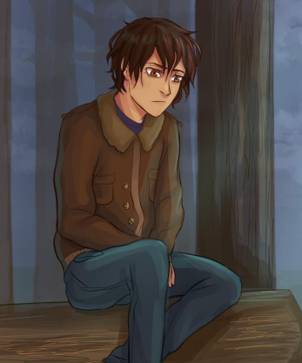
Simon quarreled with his friends and went to the forest for a walk. As a result – he got lost completely alone and without his mobile phone. It is getting dark and he is getting hungry. What might he wish at the moment? Put down 8 sentences.
____________________________________________________________________________________________________________________________________________________________________________________________________________________________________________________________________________________________________________________________________________________________________________________________________________________________________________________________________________________________________________

Exercise 2
Make sentences. Use Conditional Sentences Type 1 and Type 2.

- if / you / not finish / homework / you / not be allowed / go out / tonight
______________________________________________________________________________
- if / I / have / enough money / buy / new / sports car
______________________________________________________________________________

- you / not pass / test / unless / you / study harder
______________________________________________________________________________

- if / you / eat / all / that / chocolate / you / get / sick
______________________________________________________________________________

- if / I / be / you / I / buy / blue one
______________________________________________________________________________

- if / he / not / hurry / miss / bus / and / be / late /school
______________________________________________________________________________

- we / go / swimming / tomorrow / provided / weather /be / good
______________________________________________________________________________

- if / he / can / do / that / alone / he / not ask / your help
______________________________________________________________________________

Reading
Discuss
- Are you interested in fashion? Why/Why not?
- Do you buy environmentally-friendly products?

Read the text and answer the following questions.
1. Why is ecofashion popular?
2. What has one company managed to do with coffee grounds?
3. How many tops can one cup of coffee make?
4. What activities can you do while wearing this sportswear?
5. What has the company already used to make sportswear?

Clothes from coffee?
One of the latest fashions in the clothing business is to make clothes out of materials that don’t cause harm to the environment. This is called ecofashion and it is very popular with fashion designers. This has happened because people are worried about the environment and they want to do more to protect it.
Scientists have already found a way to make clothes from organic cotton, organic wool, and even bamboo. However, now they are taking it one step further and one company has managed to make a variety of sportswear from coffee grounds.
Many people enjoy a cup of coffee in the morning but few people know that they can make clothes from what’s left over from their favourite drink. When people finish making coffee, they throw the coffee grounds in the rubbish bin. One company is collecting this rubbish and using it to make clothes. In fact, just one cup of coffee can make up to two tops.
This new sportswear has many advantages. For example, the clothes are soft, light and comfortable. Also water cannot go through this material, so it keeps the person who wears it cool. In addition, the material offers protection from the dangers of the sun.
This new material is perfect to wear if you do very active sports like rock climbing and cycling, but you can also wear it for walking and yoga. The company which makes the clothes has already made sportswear from recycled bottles.

Project!
Discuss
- What environmentally-friendly materials do you know?
- Is it reasonable to use those materials in producing clothes/everyday usage items? Why/Why not?

Choose one of the environmentally-friendly materials and think about creating a piece of clothes\accessories out of it. Present your idea and your piece of work to your classmates.
How would the environment benefit? Put down your ideas.

___________________________________________________________________________________________________________________________________________________________________________________________________________________________________________________________________________________________________________________________________________________________________________________________________________________________________________________________________________________________________________________________________________________________________________________________________________________________________________________________________________________________________________________________________________________________________________________________________________________________________________________________________________________________________________________________________________________________________________________________________________________________________________________________________________________________________________________________________________________________________________________________________________________________________________________________________________________________________________________________________________________________________________________________________________

Reading!
Discuss
- Do you know what a hybrid is? Give examples.
- How do environment benefits from hybrids?

Read the text and decide if the following statements are true, false or not mentioned. Write T, F or NM in the boxes.
1. Hybrids don’t need a lot of fuel to run.
2. Hybrid vehicles use environmentally-friendly petrol.
3. Most people with health problems prefer to buy hybrids.
4. You can start the engine of a hybrid by just hitting the accelerator.
5. When the Prius was first released, a lot of Japanese people bought it.
6. One type of hybrid vehicle looks like a motorbike.
7. SUV was the first hybrid vehicle which had three wheels.

It’s a hybrid world
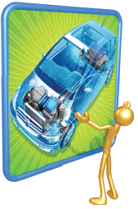
The wave of the future in automobiles is definitely the hybrid. Hybrids are vehicles that use a combination of petrol and battery power to run, making them very fuel efficient and better for the environment. Hybrids use much less petrol than a regular car and emit virtually no toxic air, which is a vast improvement for anti-pollution measures. This feature is also good for people with respiratory problems and other illnesses. Hybrids conserve energy. For instance, when the car is stopped, it shuts down everything that isn’t essential to save the battery power, and when the owner wants the car to ‘wake up’, they simply hit the accelerator. This unique feature makes a hybrid an extremely quiet car to be in, which is one of the first things people notice when riding in one.
A well-known hybrid car is the Prius. The Prius, made by Toyota was introduced in Japan in 1997, and after that they were released worldwide. Today, these fuel-efficient cars have become a common sight on roads. Other companies have made competing versions of hybrid cars, such as the Honda Insight, and the first hybrid SUV, the Ford Escape. One of the newest vehicles to join the hybrid family is the Persu hybrid. The Persu is a threewheeled vehicle, making it stand out from the rest of the hybrids. The Persu drives like a car, but looks like a motorbike. There is a driver’s seat with a passenger’s seat directly behind it and a small boot space. The Persu can achieve an amazing 120km per gallon, which outperforms almost every car on the market at the time of speaking.
Right now, other kinds of vehicles are being developed with hybrid technology. Just a few include ships, buses, military vehicles, trains and even some types of aircraft. It’s definitely an exciting time for developments in the automotive industry.

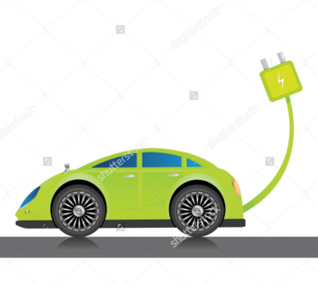
Project time!

What kind of hybrid would you like to create?

Work in pairs. Think about your personal hybrid transport. Create your own poster of your vehicle and explain what kind of an alternative energy you would use. Present your project to the classmates and vote for the best one.

Grammar
Exercise 1
Rewrite following sentences using Reported Speech.
- I am very happy to live here.
- Jane goes to her trainings every day.
- Do you like getting up early in the morning?
- Go and get me some ice-cream/
- It was a really rainy day.
- Mr and Mrs Smith smiled all day long because they had anniversary.
- I was trying to explain why I was late but she wasn’t listening.
- He had finished his project before his boss called him.
- Sue wakes up at 6 everymorning but it is 9 o’clock and she is sleeping. she was working hard yesterday because her boss gave her a lot of tasks. She had planned to wake up early and go jogging, but he changed her mind when she was writing the plan.
- I have to go to the dentist because my tooth has been aching since yesterday. My mother had told me to take a painkiller but I didn’t listen to her and my tooth was aching all day and night long. Now I understand it is important to go to the dentist regularly.

Exercise 2
Rewrite sentences using Direct Speech.
- Kelly told her parents that she wanted to become an actress.
_____________________________________________________________________________
2. Jan suggested trying to finish the project by Friday.

3. Peter told Tom that he couldn't be there on time.
_____________________________________________________________________________
4. Mary told us that she had never met Larry's brother before.
_____________________________________________________________________________
5. Charlie said that he would be working all day that day.
_____________________________________________________________________________
6. My father told me that if I lied again, I would get into serious trouble.
_____________________________________________________________________________
7. My sister wanted to know what time Brian was meeting us.
_____________________________________________________________________________
8. The policeman ordered me to give him my passport.
_____________________________________________________________________________

Game time!

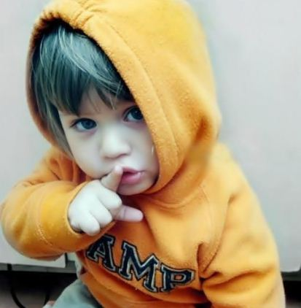
Shh… it’s a secret
Teacher whispers the phrase and the student repeats the phrase using the reported speech.
Alternatively, students sit in the circle and each student gets the stripe. In turn, they whisper sentences to each other really fast and after that they write down the sentence into their copybooks using reporting speech.

- My friend is an eccentric person: his hair used to be pink and now it is blue.
- I am visiting summer language camp this summer.
- Jane bought a really weird dress for her prom: it has a hood.
- Our teacher hasn’t finished checking our homeworks yet.
- Next year will be a perfect time for conducting a festival.
- Last week it was raining heavily.
- He will start up his own business after school.
- Students of our school can to choose there to have the lesson: inside or outside.
- In theatre you must switch off your mobile phones.
- I will visit modern art museum tomorrow, though I am not a big fan of art in general.

Mom will be back soon!
Susan’s Mother asked her to clean the room but she forgot about it as soon as mother left.
Look at the picture and put down 10 things her Mother asked her to do.
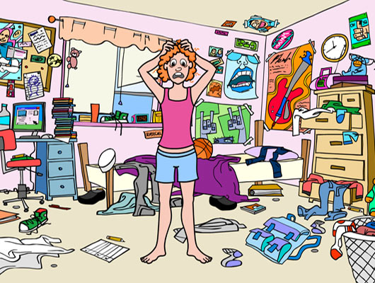
- _______________________________________________________________________
- _______________________________________________________________________
- _______________________________________________________________________
- _______________________________________________________________________
- _______________________________________________________________________
- _______________________________________________________________________
- _______________________________________________________________________
- _______________________________________________________________________
- _______________________________________________________________________
- _______________________________________________________________________
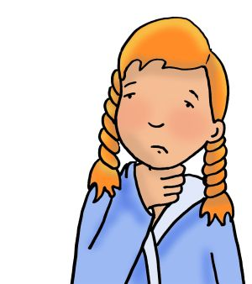
Sore throat
Your sister has a sore throat and cannot tell her friends why she cannot go to the park with them. Put down five reasons and put them into Reported Speech. 1)___________________________________________________________2)___________________________________________________________3)___________________________________________________________4)___________________________________________________________5)___________________________________________________________
A TOUR AROUND…

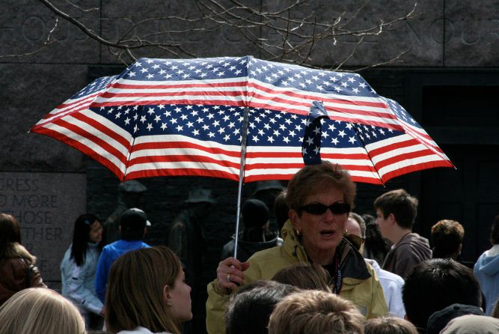
You are choosing the place to go for a school trip. Choose one of the places below and prepare for persuading your classmates and teacher to go to the place you’ve chosen. Prepare a Power Point presentation (5-7 min) in order to bring your teacher and classmates to the place you’ve chosen.
Your presentation should include the following information:
- Geographical features (location, population, etc),
- Historical background;
- 2-3 sights;
- Interesting fact/legends connected to the sight;
- Reasons to visit this year.

You may include video about the sight into your presentation.

Sights:

Cambridge
Liverpool
New York
Washington
Odesa
Chernivtsi

Milan
Rome
Barcelona
Valencia
Marcel
Paris

Reading!
Discuss.
- Have you ever collected anything? What do you think, how long does it take to accumulate a big collection?
- What are things people usually collect?
- What are the strange collections you’ve heard of?
Five sentences have been removed from the text. Choose from the sentences A-F the one which best fits each gap (1-5). There is one extra sentence which you do not need to use.
- He told Ripley about his amazing dog that did strange things, like eating pieces
of glass without getting hurt.
- Several of the museums look as though they are breaking into pieces because of an
earthquake.
- Ripley would be very happy to see that his company, Ripley Entertainment has done so well.
- The comic was so popular that, eventually, he started a radio show of the same name.
- These could be any sort of strange or interesting item from all over the U.S.
- Ripley started the company by creating a comic book where he talked about and showed
pictures of odd artefacts.
Can you believe it?
Ripley’s Believe it or Not! is an entertainment franchise started in 1918 by Robert Ripley. The line ‘believe it or not’ comes from the doubt that people had when they first saw Ripley’s strange collections. 1( ). He loved travelling all over the world and finding strange things.
He took a lot of photos and made many notes and drawings to remember the strange things he saw. Common topics in Ripley’s! were amazing sports records, little known facts about far away destinations and other items that readers of the comic had sent in to Ripley to read about. 2( ). Typically, it might be something like an odd looking vegetable, a strange trick a person could do, or an animal with odd markings on its fur. Ripley even managed to find strange and unbelievable creatures, like a ‘mermaid’ or a farm animal with an extra leg or two heads.
Ripley took these descriptions and pictures and drew his own images and printed them in his comic. 3( ). After that, he also started a cartoon for children and several TV programmes that had famous hosts who presented a variety of the strange material that Ripley loved to talk about so much. He even was the first person to publish a very early drawing of the dog that inspired the comic character ‘Snoopy’ created by the cartoonist, Charles Schulz, who wrote the Peanuts omics. 4( ).
Today, the Ripley’s company owns 35 museums in cities all over the world, called ‘odditoriums’. 5( ). One of the most impressive is the museum in Panama City Beach, Florida, which is shaped like a giant boat that’s sinking into the water!
Ripley’s also owns cinemas, and many other entertainment venues. They even own several aquariums, and, in fact, the Ripley’s aquarium in Gatlinburg, Tennessee has the longest underwater tunnel in the world.

