Grammar
Exercise 1.
Circle the correct option.
Simon Thatcher lives/is living in Birmingham. He is being / is a doctor. He likes/is liking his job because he can help people and he meets / is meeting new people every day. This week, he isn’t working / doesn’t work . He are/is on holiday. Simon love / loves trying different things when he is on holiday. At the moment, he is learning / learns to skateboard.
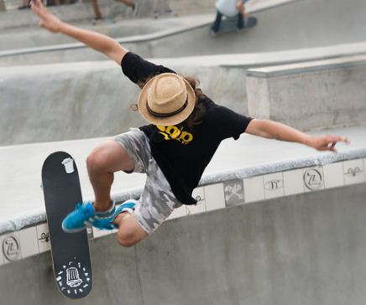
Skateboarding doesn’t / isn’t really difficult to learn, but skaters must always control their balance. Skaters stand / are standing on the board and push / are pushing themselves off the ground in order to move. Usually skaters are moving / move really fast, jump / are jumping and perform / are performing different tricks. It is being / is kind of scary but at the same time very exciting.
Simon looks forward / is looking forward to the next summer when he is mature enough to take part in Birmingham Skating Competition.

Exercise 2.
Fill in the blanks with present continuous or simple present:

1. The children ………………………….. (play) outside now.
2. She usually ………………………. (read) the newspaper in the morning.
3. I …………………………… (do) my homework now.
4. I ………………………… (eat) my dinner now.
5. ……………………………. (you / want) a pizza?
6. They …………………………….. (watch) TV now.
7. I ……………………………. (not / like) spaghetti.
8. The baby …………………………. (sleep) now.
9. My mother usually …………………. (cook) dinner in the evening.
10. He …………………….. (write) a letter to his pen-friend every month.
11. She ………………………. (not / like) football.
12. Mary ………………………….. (listen) to music now.
13. Tom usually ……………………(drink) coffee, but he …………………. (drink) tea now.
14. We ………………………. (go) to the disco tonight.
15. ………………………… (he / go) to work by bus everyday.

Exercise 3.
Translate the following story into English.
Мене звуть Михайло і мені 45 років. Зараз я живу з моєю родиною в новій квартирі на першому поверсі багатоповерхового будинку. Вранці я люблю пити каву на кухні та дивитися на вулицю, де мої сусіди збираються у справах. Зараз ми з дружиною сидимо на кухні і дивимось на нову білу машину сусіда. Вся машина вкрита сірими цятками і нам видається це дивним. Ми не вважаємо, що можна так замастити нову машину за один день. Я телефоную сусіду і кажу йому: «Привіт! Мені здається, тобі варто помити машину, щоб вона виглядала чистішою». Через годину я бачу як мій сусід миє свою нову машину, але плями залишаються на тому самому місці! Я не вірю, що це може бути правдою і відчиняю вікно, для того,щоб сказати йому про це. В той час як я відкриваю рота, щоб гукнути сусіда я усвідомлюю, що плям немає…
Reading

Discuss
- Is it possible to earn much money by selling an idea?
- Can you remember any ideas which helped their authors to become rich and famous?

Read the text and decide if the statements below are true, false or not mentioned. Write T, F or NM.
BILLION DOLLAR IDEAS
Mark Zuckerberg is best known as one of the creators of the
highly successful social networking site, Facebook. Zuckerberg had
been interested in computers from a very early age. He created
his first computer program when he was in high school. In fact, he became so well-known, that both AOL and Microsoft asked him to work for them but Zuckerberg decided that he would rather go to college, so he went to Harvard. It was while he was at Harvard that he and
his roommate created Facebook.
The idea of Facebook came from the actual facebooks that many colleges use with students’ names and pictures. Zuckerberg took the idea of the college yearbook, and computerised it so that it was on the Web. The idea spread to other colleges across the US and became very popular in a short amount of time. Since Facebook started in 2004, the website has added many new and exciting features including games and applications. Today, Facebook has over 400 million users worldwide, and Zuckerman has proved himself quite the businessman, becoming a billionaire in his early twenties. There is even a film based on the creation of Facebook starring Justin Timberlake.
YouTube is a very popular video sharing website created by Chad Hurley,
Steve Chen and Jawed Karim in 2005. In only about a year and a half of the site being online, the creative team sold it to Google for almost 2 billion dollars, making the three founders billionaires in their mid-twenties.
The company was founded in a small office above a pizza restaurant and
a Japanese restaurant in San Mateo, California. The three founders created
the website because they wanted an easy way to share large video files
with each other online. At that time, it was impossible to send such a large
file through e-mail and there weren’t any other free websites that existed
which allowed posting videos. It’s well-known that YouTube started with
just one video: Me at the zoo. It’s a short clip of founder Jawed Karim at
the San Diego Zoo that can still be found on the site today. This early post
paved the way for all other videos to come and showed that anyone could
upload simple moments from everyday life for the whole world to see. The website grew very fast, and within the first 8 months of operation, more than 65,000 videos were uploaded every day. YouTube is so popular that its daily bandwidth cost is around one million dollars. It’s currently number four in the list of the most visited websites and has an estimated one billion views per day all over the world. Today, the YouTube offices have moved from a tiny office above a couple of restaurants to its own large office building in San Bruno, California. Now, YouTube is as popular as ever, and getting better each day.

1. Mark Zuckerberg started working for Microsoft when he was a college student.
2. Mark Zuckerberg graduated from Harvard.
3. Mark Zuckerberg acted in a movie about his life.
4. YouTube was created by a group of people.
5. The founders of YouTube spent about one million dollars for their new office.
6. YouTube’s first video is no longer on the site.

Check your knowledge!

Choose the correct option.

- Jane isn't a Canadian. I ________ she comes from the USA.
A. think
B. am thinking

2. Have a look! Barbara ________ in the street.
A. dances
B. is dancing

3. It ________ here in autumn and people prefer staying at home.
A. rain
B. is raining

4. I ________ you're crazy!
A. believe
B. am believing

5. Don't try to be kind on him. He ________ it!
A. hates
B. is hating

6. Once a week, I ________ an art class.
A. attend
B. am attending

7. Michael is rich — he ________ a Porsche.
A. has
B. is having

8. You won't find Mike in his room. He ________the guitar in the garage.
A. play
B. is playing

9. It ________ hard — let’s stay at home.
A. snows
B. is snowing

10. I ________ to Washington for a weekend on Fridaynight. Do you want to come?
A. go
B. am going

11. I never ________ breakfast in the morning.
A. have
B. am having

Vocabulary
Exercise 1
Match the adjectives with the description

bright eccentric flexible sincere mean sympathetic naive sly

- It has always been easy for Mary to change the class or move to another town.
- My mother is not able to hide her emotions – everything is written on her face.
- It was so easy to trick me when I was a child – I believed everyone.
- Our math teacher isn’t a kind person. He never tells us we are good students, although we are the best class.
- My brother could solve second grade tasks when he was five.
- However this girl has blue hair and piercing in her nose, she is a really kind person and a good friend.
- My best friend can always listen to me and comfort me in any condition.
- This boy can trick anyone if he wants to get a candy.

Exercise 2
Look at the pictures and give characteristics. Provide explanation.
E.g.: I think that the man on picture one is a sly person, because he is wearing orange clothes and looks like a fox to me.

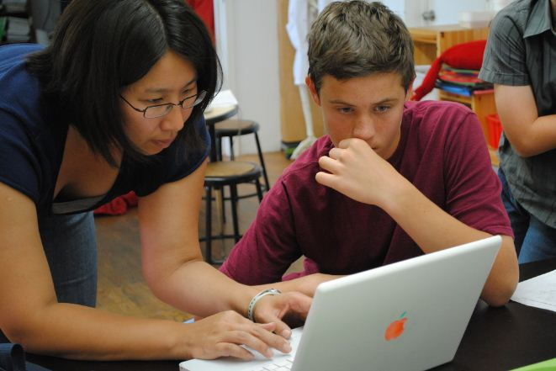

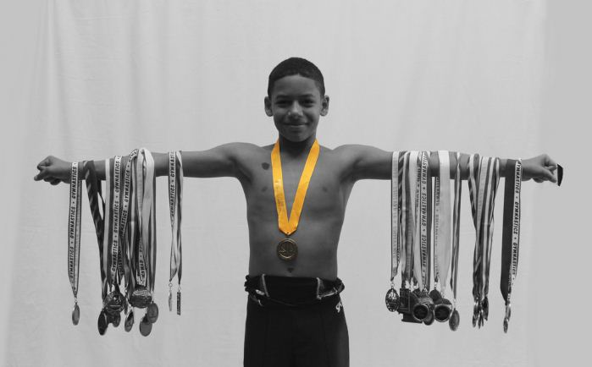

Grammar

Exercise 1.
Put these sentences in the correct order.

1) used to / study / very hard / Lucy _______________________________________________________
2) long hair / He / used to / have __________________________________________________________
3) Suzy / go / used to / the cinema. ________________________________________________________
4) They / go out / used to / the evenings / in _________________________________________________
5) used to / wonderful beach / There / be / here ______________________________________________
6) travel / used to / a lot / We _____________________________________________________________
7) She / play / tennis / used to ____________________________________________________________
8) James / his bike / ride / used to / in the park. _______________________________________________

Exercise 2.
Use the sentences from exercise 1.

Put sentences 1-4 into negative form.
a) _____________________________________________________________________________
b) _____________________________________________________________________________
c) _____________________________________________________________________________
d) _____________________________________________________________________________
Put sentences 5-8 into interrogative form.
e) _____________________________________________________________________________
f) _____________________________________________________________________________
g) _____________________________________________________________________________
h) _____________________________________________________________________________

Exercise 3.
Change the sentences using ‘used to’ where possible.
- Jane was a good swimmer.
________________________________________________________________

- When Sandra was a child she went to her grandparents´ farm for her summer holidays.
________________________________________________________________

- What kind of food did you hate when you were ten years old? Vegetables. I never hate vegetables.
________________________________________________________________

- We worked in our garden all day yesterday.
________________________________________________________________

- James didn´t like soup, but now he does.
________________________________________________________________

Exercise 4.
Write about yourself now. Create one sentence for something you used to do but don't anymore, and one sentence for something you did not use to do but now do.

4.1. ______________________________________________________
__________________________________________________________
__________________________________________________________

4.2. ______________________________________________________
__________________________________________________________
__________________________________________________________

The Present and the Past

Compare celebrities before and now. What has changed?
Name minimum 3 things.

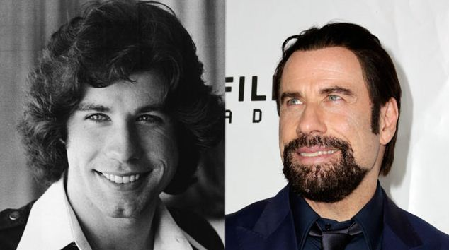

John Travolta

Nicole Kidman

Justin Bieber

Grammar

Exercise 1.
Fill in the sentences the verbs either the Past Simple or Past Perfect.

- When I ________(come)home my mother ________(already/cook) dinner.
- By the time she ________(get) to the cinema her boyfriend ________(already/buy) the tickets.
- She ________(already/ study) German before she ________(move) to Berlin.
- When they ________(enter) the room the concert ________(already / begin)
- My son only ________(play) computer games after he ________(finish) studying.
- I ________(send) a message to my friends before I ________ (meet) them.
- They ________(not have) much fun by the time Lauren ________(arrive).
- He ________(call) her four times before she ________(answer) the phone.
- Jason ________(find) a new job when he ________(go) to London.
- After we ________(pay) we ________(leave) the restaurant.
- She ________(lose) the handbag her mother ________(give) her for her birthday.
- Julia ________(go) to the doctor because she ________(not eat) well for five days.
- When he ________(reach) the station the train ________(already / leave).
- When the plane ________(land) they ________(already/ arrive) to the airport.

Exercise 2.
Speculate on the following situation. What had happened?

Anna was crying and her mum looked angry. What had happened?
_____________________________________________________________________________________
Stan’s underpants were on his head and he was wearing a dress. What had happened?
_____________________________________________________________________________________

Masha was running down the street at midnight. What had happened?
_____________________________________________________________________________________

Alex was wearing a big coat and had a chicken in her pocket. What had just happened?
_____________________________________________________________________________________

Sasha was crying with laughter. What had just happened?
_____________________________________________________________________________________

A strange woman was chasing Paul down the Metro stairs. What had just happened?
_____________________________________________________________________________________

I found Ann crying in the classroom. What had happened?
_____________________________________________________________________________________

Alex went to his room, but walls had different color. What had happened?
_____________________________________________________________________________________

When Kate woke up she found out that the room was full of sheep. What had happened?
_____________________________________________________________________________________

Mary was wearing one shoe and holding a dead rat. What had happened?
_____________________________________________________________________________________
Day backwards!

Interview your partner about his her activities yesterday. Ask 10 questions and present the information about the day backwards. Be ready to continue the story of another student.
Example: Olena went to bed at 11 p.m., but before that she had watched a new episode of The Big Bang Theory. Before watching the BBT she had played with her little sister.

Question | S1  Name | S2  Name | S3  Name
1.
2.
3.
4.
5.
6.
7.
8.
9.
10.

Reading!

Complete with the Present Perfect Simple, the Present Perfect Progressive or the Past Simple of the verbs in brackets.

__________ you (ever/hear) of anyone getting paid to stay in bed for up to two months? Too good to be true? Well, it is! A team of space scientists __________ (want) to investigate the changes that take place in the human body during long space journeys so they __________ (start) carrying out a series of experiments a few months ago. They __________ (put) advertisements in several newspapers for volunteers who were willing to spend 60 days in bed. They were expected to eat, drink, watch TV and even have a shower while lying down! Dr Vladimir Tursunov, one of the scientists that __________ (be) involved in the project since it __________ (start), said: ‘Thousands of people __________ (apply) when they __________ (see) the advertisement in the paper. It __________ (be) really difficult to decide which ten would be the most suitable. The participants __________ (already/be) exhausted because of all the intense medical examinations. Now, however, they have all the time in the world to relax...’ . Alfred, one of the participants in the programme, __________) (lie) in bed for 32 days. ‘At first I __________ (find) it hard, but now I __________ (become) quite used to it. Plus, the money is really good; how many people do you know who earn €4500 in just two months’? Sometimes it pays to sleep on the job!

Discuss
Would you like to take up such job?
What are its benefits/drawbacks?

Reading!

Read the text and make the list of Daniel’s achievements.

Genius
Daniel Paul Tammet can do huge calculations in his head. His understanding of numbers is unusual and difficult to explain. He wasn’t an ordinary child. He had epileptic seizures and atypical behaviour when he was a boy.
However, this did not stop him from being an excellent student who could experience numbers and language in an unusual way. When he grew older, he was finally diagnosed with high-functioning autistic savant syndrome and could finally understand what made him different to others.
The young genius first came to public attention when he was able to recite ð (pi) from memory to 22,514 decimal places in 5 hours and 9 minutes. Nobody had managed to do that up until then. He also speaks a variety of languages, including English, French, Finnish, German, Spanish, Lithuanian, Romanian, Estonian, Icelandic, Welsh and Esperanto. He is able to learn new languages very quickly. A Channel Five documentary asked him to prove this and Tammet surprisingly learnt Icelandic in just a week.
Tammet worked as a volunteer English teacher in Lithuania before starting the online language learning company, Optimnem. Knowing that he can learn things in ways that others can’t, Tammet is now trying to teach others how to be more successful in learning a language on their own.

Mark the following statements as True or False

1. Daniel Tammet wasn’t an ordinary child so he wasn’t a very good student.
2. Daniel Tammet can speak eleven languages.
3. It only took Daniel Tammet seven days to learn a language.
4. Daniel Tammet is a teacher in Lithuania.
5. Daniel Tammet has created a site where volunteers teach foreign languages.

Grammar
Exercise 1
Fill in the correct forms of Past Simple or Past Continuous.

One day my mother _____ (cook) in the kitchen with the window open, when she (hear)___________kids screaming loudly in the yard. They (scream)____________and (shout)_____________and she (get interested) what (happen) ___________ . Then she (notice)___________that they (look)____________at something on the ground. My mom (call)______ them and (ask)_______ what _________(go on). When kids (see)__________her they (scare)______________and (run away)________________. When my mother (come) ___________ she (see)_______ a little bird with a broken wing. My mother (take) ________ the bird home and (call)_______ the vet. The bird (live)_______ at our home for two moth and when it (get) _____ healthy we (let)_______ it go.

Exercise2
Fill in the correct forms of Past Simple or Past Continuous.
People refer to Agatha Christie as ‘The Queen of Crime’ because she ________ (write) many crime
novels, short stories and plays. While Agatha Christie ________ (serve) as a nurse during World War I, she ________ (learn) a lot about poison. Later, she ________ (use) this knowledge in her stories. Her first novel, The Mysterious Affair at Styles, ________ (come out) in 1920. One of the
characters in that book was the detective Hercule Poirot. This character ________ (appear) in another 25 novels. In 1930, while Agatha Christie ________ (travel) in the Middle East, she ________ (meet) Sir Max Mallowan. They ________ (get) married that same year.
She ________ (go) on a lot of trips with her husband in the Middle East. These trips ________ (give) Christie ideas for some of her famous books. In 1952, she________ (write)
The Mousetrap. This ________ (be) one of the most popular plays ever and it ________ (receive) The New York Drama Critics’ Circle Award in 1955.

Exercise 3
Translate following sentences into English.
- Я здав роботу два тижні тому.
- Майк прочитав цю книгу минулого літа.
- Телефон задзвонив, коли Джейн читала книгу.
- Він прокинувся, поснідав і пішов на роботу.
- Тато готував млинці на сніданок, поки мама накривала на стіл.
- Коли ти спік цей пиріг? – Я спік його вчора.
- Чим ти займався, коли Даня прийшов до тебе в гості? – Я як раз дивився нову серію «Ходячих Мерців».
- Чи м ти займався вчора ввечері? - Я готував вечерю для своїх друзів.
- Ти грав в футбол вчора? – Так, я був на полі весь день.
- Я телефонував тобі вчора о 12, де ти був? – Вибач, я не чув. Я плавав у басейні.
- Ти був вдома о 17? – Так.

Gametime!

You have to split into pairs of policemen and criminals. Use the cards and think over the question and information you are going to provide. The task of the policemen is to find the criminals/

Policemen Card
Ask about:
- where and when they met _______________________________________
- what the weather was like _______________________________________
- what their friend was wearing _______________________________________
- where they were at 10 pm last night _______________________________________
- what they were doing at 10 pm last night _______________________________________
- what they ate or drank at the party _______________________________________
- who they talked to at the party _______________________________________
- what noises they heard _________________________________
- what/who they saw when they heard the noise ___________________________________
- what was he/she/they doing _______________________________________

Suspects Card
Get together with your partner and think about:
- where and when you met _______________________________________
- what the weather was like ______________________________________
- what your friend was wearing _______________________________________
- where you were at 10 pm last night _______________________________________
- what you were doing at 10 pm last night _______________________________________
- what you ate or drank at the party _______________________________________
- who you talked to at the party _______________________________________
- any noises you heard _______________________________________
- what/who you saw when you heard the noise ____________________________________
- what was he/she/they doing _______________________________________
Reading
- Look at the picture. Do you know this building? How many stores do you think it has? Skim the article and check your answers.
- Read the article and answer the following questions. Choose a, b, or c.
What a view!
Dubai is certainly one of the most well-known cities in the Middle East. Located in the United Arab Emirates, it is a glittering jewel of a city in the otherwise sandy desert.
One of the reasons the city ‘glitters’ is because of its extravagant construction projects. It’s certainly easy to call Dubai a ‘tall’ city, because it has some of the world’s tallest buildings.
Burj Khalifa is one of the tallest man-made structures in the world. Construction began in 2004 and the building opened in January 2010. Burj Khalifa is an amazing 828 metre high building! Most of the really tall skyscrapers are only used as office buildings, but Burj Khalifa has also got residential flats! The skyscraper is groundbreaking in many ways. It is the building with the most floors (180), the highest swimming pool in the world, the highest observation deck, and the first Armani hotel anywhere in the world. The hotel takes up 15 floors in the lower part of the building. Burj Khalifa also has the highest lift system in the world, as well as the fastest. You can take any of the 57 lifts from the first floor and be on the 124th floor in about 60 seconds. The building can hold around 35,000 people at a time! There are also several ‘sky lobbies’ where people can see the amazing panoramic views for many kilometres from special digital binoculars.
Burj Khalifa is located in a part of the city known as Downtown Burj Khalifa. This area is a large-scale real estate project that includes parks, hotels, entertainment venues and beautiful man-made ponds and fountains. In fact, the same people who made the Dubai Fountain, also made fountains for resorts and casinos in Las Vegas. The fountain has got lights and can shoot water almost 150 metres into the air. It’s over 275 metres long; that’s more than the length of two football fields!
It’s so large that people can see it from about 30 kilometres away on a clear day. Also, in Downtown
Burj Khalifa there is the Dubai Mall, the largest shopping mall in the world. Nearby is the Burj Al Arab hotel, the world’s second largest hotel. This magnificent hotel sits on a man-made island and looks like a ship’s sail. Dubai has got other tall hotels too, including the Rose Tower, a 72-storey building (333m) and the world’s tallest building used exclusively as a hotel. In fact, Dubai boasts four of the world’s five tallest hotels. With Rose Tower in the first place, Burj Al Arab in the second, Jumeirah Emirates Towers Hotel and The Address Downtown Burj Khalifa following in the list, it must be hard to decide which to visit. No matter where you go, the view is great!

1. Why does Dubai ‘glitter’ in the desert?
a. because of its location
b. because it’s in the middle of the desert
c. because of its unique buildings

2. Why is Burj Khalifa special?
a. because of its height
b. because of what it is used for
c. both of the above

3. What is different about Burj Khalifa compared to other skyscrapers?
a. There are only offices in the building.
b. People can also live there.
c. It offers panoramic views of the city.

4. What isn’t true about the Dubai Fountain?
a. You can see it from very far away.
b. It was created by people who made similar
structures.
c. You have to pay to visit it.

5. What is special about the Burj Al Arab hotel?
a. It is near the Dubai Mall.
b. It is built on an island which is not natural.
c. It’s on a boat.

Speaking!
Use the presentation ‘Kyiv on foot’ and conduct a tour around the capital city.
Identify the sight and provide all information about it.
Prepare more information at home and present it to your classmates.

Test your skills!

Choose the word or phrase to make correct sentence.

1. Could you tell me ________ while I was out?
a. who called b. who did I call c. did you call d. you called

2. Brenda to wake up early in the morning until she started working. Now, she wakes up at 7 every
morning.
- used b. didn’t use c. uses d. is used

3. Can you tell me where a good Italian restaurant?
a. can I find b. I find c. did I find d. I can find

4. Who to your birthday party?
a. did you invite b. invited c. you invited d. invites

5. Paul used climbing some years ago, but he gave it up when he got married.
a. going b. goes c. to go d. went

6. What time on Fridays?
a. is the train leaving b. does the train leave c. the train leaves d. the train is leaving

7. Last week I a terrible headache and didn’t go to work.
a. have b. am having c. used to have d. had

8. I to work, but today I took the bus.
a. usually drives b. am used c. usually drive d. am driving

9. What for Jake’s birthday?
a. you bought b. you are buying c. didn’t you buy d. did you buy

10. My parents Rome in two months.
a. visited b. visit c. are visiting d. used to visit

Grammar!
Exercise 1
Put the verb into the most suitable form. Use Past Continuous, Past Perfect or Past Perfect Continuous.

I ______ (hear) noise next door and _____(get) scared at first, but then I _______(realize) that our neighbors _________ (have) a birthday party and ________(remember) that they _______(invite) us to the party. When I _____(tell) my wife about it we _________(realize) that we _________(forget) to buy the present. We were really upset because we ________ (shop) all day before and _____( not get) any present. Suddenly my wife ______(remember) that there was one picture we ______(paint) during last week and it ______ (may) be a perfect present for our neighbors. When we ____(come) all guests ________(talk) silently because they ________ (party) for a couple of hours but hosts ____(be) happy to see us, though they ______(not like) our present at all.

Exercise 2
Match
- The ground was wet. | a) Something had been burning.
- She was carrying lots of bags. | b) He had been working on it for years.
- Her hands were dirty. | c) The children had been cooking.
- She had red eyes | d) She had been planting flowers in the garden.
- He got sacked. | e) He hadn’t been working at all.
- The kitchen was very dirty. | f) She had been crying again.
- They were very tired when they arrived. | g) She had been shopping
- They smelled smoke. | h) They had been driving for ten years.
- He was happy when it was finished. | i) It had been raining

Exersice 3
Complete the sentences with your ideas using Past Perfect Continuous

He felt really exhausted…
Teacher was extremely angry…
Students finished their exam with smiles on their faces…
Kids didn’t feel hungry…
The streets were wet…
The fridge was filled with food…
Children were sleeping tight…
My phone battery was low…

Grammar!
Exercise 1
Circle the correct answer.

1. If we _____ them, we will invite them for dinner.
a. will see b. see c. have seen
2. You can use my computer _____ yours doesn’t work.
a. if b. if not c. unless
3. Jenny______ the 8 o’clock news tonight if she has time.
a. watches b. will watch c. doesn’t watch
4. A businessman won’t be successful_____ he works hard.
a. if b. if not c. unless
5. If Sandra_____ enough time, she would go to the gym.
a. will have b. would have c. had
6. I won’t go to the bank unless I______ money.
a. need b. don’t need c. will need
7. If you are on a diet, you______ junk food.
a. won’t eat b. wouldn’t eat c. mustn’t eat
8. Howard will buy a car ________his driving license.
a. unless he gets b. if he gets c. if he doesn’t get
9. If I were you, I _______ skiing this weekend.
a. won’t go b. wouldn’t go c. shouldn’t go

Storytelling Time!

Play a game of a snowball. Choose the beginning of the sentence and finish it according to your point of view. Next student develops your idea like in example.
E. g.:
S1: If I pass all my tests successfully, I will have plenty of free time on holidays.
S2: If I have plenty of free time on holidays, I will sleep till noon…. etc.

If I am stressed out…
Unless my best friend keeps my birthday in mind…
If the topic is not familiar to me…
If my grandparents are willing to visit me…
If I didn’t get along with my cousin…
Unless I took into consideration what teacher was saying…
If I were invisible…
Unless I was sure in what I saw…

Writing!

You were asked to give advice to teenagers in the local magazine. Read about Brian’sproblem. Use the following phrases and write sentences with your advice.

If I were you... If I were in your position... If I had the same problem...

‘Hello, I am Brian. I am 15 and I have no friends. I am the best student in my class and I adore science and soccer, but it seems really difficult to me to find common language with other people. They all seem to see my marks but not me behind. Help me! What shall I do?’

________________________________________________________________________________________________________________________________________________________________________________________________________________________________________________________________________________________________________________________________________________________________________________________________________________________________________________________________________________________________________________________________________________________________________________________________________________________________________________________________________________________________________________________________________________________________________________________________________________________________________________________________________________________________________________________________________________________________________________________________________________________________________________________________________________________________________________________________________________________________________________________________________________________________________________________________________________________________________________________________________________________________________________________________________________________________________________________________________________________________________________________________________________________________________________________________________________________________________________________________________________________________________________________________________________________________________________________________________________________________________________________________________________________________________________________________________________________________________________________________________________________________________________________________________________________________________________________

Grammar!

Exercise 1
Join the sentences using who, which, where or whose.

- That’s Sally Brown. Her seven brothers and sisters all live abroad.
__________________________________________________________

- The leather jacket was very expensive. I didn’t buy it.
__________________________________________________________

- That new actor is very talented. I saw his new film last week.
__________________________________________________________

- Mike works at a restaurant. Famous people often eat there.
__________________________________________________________

- Tina was talking on the phone with Angie. She’s her best friend.
__________________________________________________________

- That’s the boy. He lives next door.
__________________________________________________________

- There’s the house. My uncle bought it.
__________________________________________________________

- Here are the children. Their bikes are in the street.
__________________________________________________________

- Where’s the teacher? Jane was talking to her five minutes ago.
__________________________________________________________

- Yesterday I went to a cafe. Mark’s brother works there.
__________________________________________________________

- My mum bought me a jacket. It’s made of leather.
__________________________________________________________

- They live in a flat. I used to live there three years ago.
__________________________________________________________

- There’s the dentist. She fixed my front tooth yesterday.
__________________________________________________________

- Henry has got a hat. It is red, green and blue.
__________________________________________________________

- Claire is a writer. She is very famous.
__________________________________________________________

- It is a salad. It tastes delicious.
__________________________________________________________

- This is a picture. It was painted by Joseph Turner.
__________________________________________________________

- He is a teacher. He is very popular.
__________________________________________________________

- It’s a machine. It makes pasta.
__________________________________________________________

Exercise 2
Cross out the relative pronoun in the sentences where possible.

1 The nurse who is looking after my mother is very kind to her.
2. Luggage that is left unattended will be taken away by police.
3. Who’s that good-looking man who is talking to Alice?
4. All the rubbish that is thrown away in the sea is a real danger to health.
5. Do you know the man who is standing near the door?

Who is it?

Choose one person from the list. Explain to your classmates who this person is. You can give up to 5 hints. Make up sentences using relative pronouns.
Example: This man is an actor who was born in Great Britain.
He became famous when he was a child.
His country is where Stonehenge is.
A story for children is why he became popular.
He is a person, whose name is associated with magic.
He is… Daniel Radcliffe

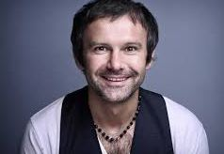
Svyatoslav Vakarchuk
Potap
Tom Cruise
Brad Pitt
Lilia Podkopaeva
Yana Klotchkova
Tina Karol
Jamala
Olga Sumska
Olga Kurilenko
Volodymyr Zelenskiy
Bohdan Stupka
Lina Kostenko
Liubko Deresh

Reading!
Bizarre sports that actually exist
http://www.wonderslist.com/top-10-bizarre-sports-actually-exist/
You are going to read the information about unusual kinds of sport. Read the texts and make the list of the necessary equipment for each sport.

Underwater Hockey
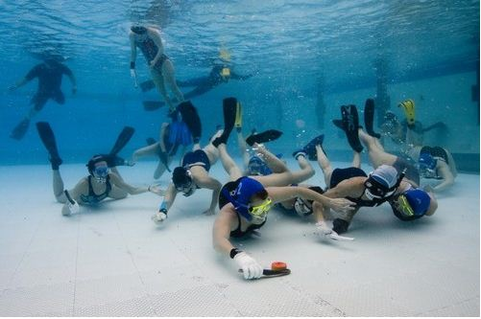
This might be hard to understand but just picture hockey played under water. Simple? Well according to spectators, not so much. Just like field hockey, ice hockey or air hockey, the objective is to use a stick to hit a puck or ball into the opponent’s goal. Because it is played under water, the sport is accordingly named Octopush by participants. The teams consist of 6 players and are surprisingly very common around the world although having a huge spectator crowd is practically impossible because of the pool territory to be more precise.

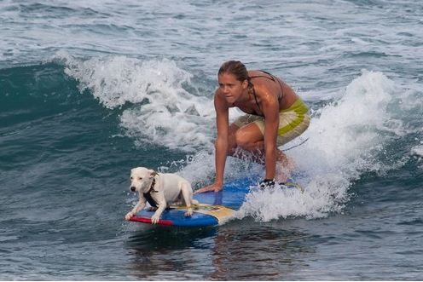
Dog Surfing
When we say a dog is a man’s best friend, we didn’t realize how far that really went. For all the surfing enthusiasts out there, here’s a sport you can share with your favorite furry friend. Dog Surfing is something that is characterized as an exciting and “way too cute” sport. It started in San Diego and spread across most parts of America and is very common in Australia as well. What is the objective of this sport? As simple as training your dog to stay upright on a surf board while catching some waves. There are many competitions that take place in California on a yearly basis and they attract crowds to the event. Our only wish is that the prize is not just a doggy treat.

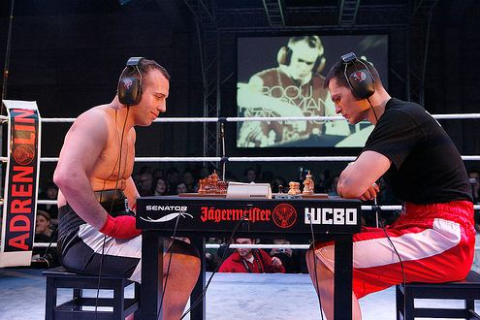
Chess Boxing
This is a sport that is a perfect mash up of brains and muscle. The participants need to be skilled at both chess as well as boxing as this sport includes both activities. There are changing rounds of chess and boxing which allows the boxer to take a break and restore energy while working the mind to knockout their opponent with a checkmate instead of a right upper cut. People like the sport because it is not all about brutality and neither is it all about boring slow moves of chess. It’s a perfect marriage. Whoever invented it, there’s just one word – genius.

Cheese Rolling
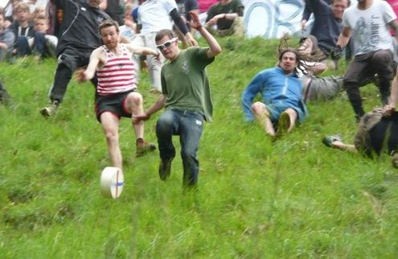
Food has played a part in some sports or competitions for thousands of years and this is not very different. Cheese rolling is something that has been around for over 200 years and is still practiced today. During the Spring Bank Holiday in England, people gather at the top of Coopers Hill and prepare for something very exciting. At the top of the surprisingly steep hill, a judge rolls a round of cheese down the slope and the participants follow. People try to run down the slope but quite obviously end up rolling or sliding down like the cheese. The winner of the race wins the round of cheese as well as a few bruises and scars and if they’re lucky, maybe a broken bone or two.

Discuss which one you find the most/least attractive for yourself.
Answer the questions.
- What kind of sport do you like the most/the least? Why?
- Would you like to take part in any of it?
- What is the most unusual kind of sport you’ve ever hear about? Describe it.

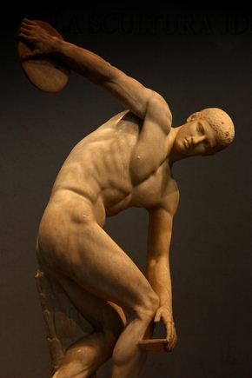
Project
Be original!
Split into groups of three and invent your own kind of sport. Think about:
- place
- participants
- equipment
- clothes for your sport
- rules
- scoring system
Create a short presentation and tell about your game to your classmates.

Grammar
Exercise 1.
Fill in the gaps with by/with (by →person, with →ingredient/material/instrument).
- These photos were taken _____ my mother.
- The box was opened __ scissors.
- The walls have been painted in blue ___ paint.
- The stranger was asked about time ___ me.
- The house will be redecorated ____ us next week.
- The tablecloth is always put on the table ___ Max.
- The student was told off ___ the teacher for coming late.
- The lock was broken __ a hammer ___Mark.
- The cake is beautifully decorated ___ roses ___ the cook.
- Animals are shot __ a hunter ___a gun.

Exercise 2.
Make the list of objects around you and comment on their origin using Passive Voice and prepositions ‘by’ and ‘with’.

- ____________________________________________________________
- ____________________________________________________________
- ____________________________________________________________
- ____________________________________________________________
- ____________________________________________________________

Exercise3.
Rewrite the sentences using Passive Voice.
- They must deliver the parcel today.
____________________________________________________________
- He hasn’t finished his homework yet.
____________________________________________________________
- Had he watered the plants before leaving the house.
____________________________________________________________
- Ukrainians cook borsch from meat and vegetables.
____________________________________________________________
- The children will find the book after lunch.
____________________________________________________________
- Christopher Columbus discovered America.
____________________________________________________________
- Hooligans smashed the kitchen window.
____________________________________________________________
- A lot of children do homework at school.
____________________________________________________________
- My neighbors saw the thieves.
____________________________________________________________
- The teacher asked Paul to take part in competition.
____________________________________________________________

Exercise 4.
Make up questions using the phrases given and provide two answers(+/-). Use Passive Voice.

1. My / car / repair?__________________________________________________
Answer 1:__________________________________________________________
Answer 2:__________________________________________________________
2. Your composition / rewrite?_________________________________________
Answer 1:__________________________________________________________
Answer 2:__________________________________________________________
3. Doctor / call / at the moment?________________________________________
Answer 1:__________________________________________________________
Answer 2:__________________________________________________________
4. Lots / e-mails / send / Roger / last week?________________________________
Answer 1:__________________________________________________________
Answer 2:__________________________________________________________
5. Children / follow / two strangers / yesterday morning?_____________________
Answer 1:__________________________________________________________
Answer 2:__________________________________________________________
6. Cake / sell / school fair / charity?______________________________________
Answer 1:__________________________________________________________
Answer 2:__________________________________________________________
7. Flower / plant / garden / Mom?_______________________________________
Answer 1:__________________________________________________________
Answer 2:__________________________________________________________
8. Parcel / deliver / by tomorrow?_______________________________________
Answer 1:__________________________________________________________
Answer 2:__________________________________________________________
9. Sandwich / eat / children now?________________________________________
Answer 1:__________________________________________________________
Answer 2:__________________________________________________________
10. Funny hat / wear / Kate / last winter?__________________________________
Answer 1:__________________________________________________________
Answer 2:__________________________________________________________

Exercise 5.
Translate following sentences into English Using Active or Passive Voice (or both if possible).

- Я сподіваюсь, що вони не загублять мою посилку.
- Мій тато ремонтує машину.
- Люди вважають, що Стоунхендж побудували друїди.
- Кеті прибирає в будинку.
- Кароліна тільки-но завершила підготовку до свята.
- Вчителька розпитує дітей про їх канікули.
- Маляри фарбують паркан білою фарбою.
- Ерік готує лазанью кожної неділі.
- Вчитель збирається дати нам багато домашнього завдання на літо.
- Вчора студенти взяли участь в демонстрації.

Exercise 6.
Fill in the gaps using so, such, so many, such a lot of
- – Why didn’t you come to the cinema? You’d promised to.
– I am sorry; traffic was so heavy, that I didn’t manage to come.
- – Hello, are you going to watch football with us tonight.
– Of course! I hope it will be ______ an exciting game.
- – H&M are having huge discounts this week, let’s go there.4
– I don’t think I might go. There are _________ people there that I am afraid to come in.
- – Did you enjoy the play last night?
- – Not a chance. It was ____ boring that I almost fell asleep and moreover, not ______ people came in order to see it despite all advertisement.

Project

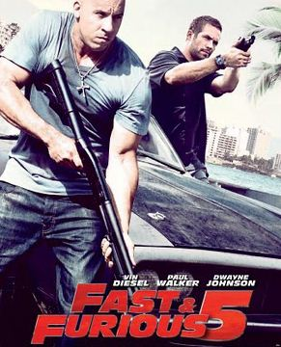
Choose one of the action films you’ve seen recently and create a poster about it including the following information:
- Director, cast
- Characters
- Plot (short description)
- Favorite part
Remember! Do not forget to attach photos to your poster and highlight interesting facts and information.

Reading
Read the text and match the questions with the paragraphs.
People Who Make a Difference
This week, People Who Make a Difference interviews Antonia Trovatelli. As a member of a search and rescue team, Antonia often goes into difficult, and even dangerous places, to help others.
- I’m a student at Georgetown Tech, studying nursing. In high school, I had a teacher who was a member of a search and rescue team and he used to tell us exciting stories about saving people’s lives. I’d always liked the outdoors, and I wanted to help people, so I decided to volunteer. I have been part of the team for three years now.
- Well, many people come here to go hiking or mountain climbing because Georgetown is close to the Stormy Mountains Nature Reserve. If a climber gets lost or injured, then we are sent to look for them. I am part of a foot rescue team. That means we search for people on foot. We search any time and in all weather. Even if the call comes in the middle of the night, and it’s raining or snowing, we have to get up and go!
- First, the police call the team members and tell us where to meet. Of course, we don’t know how long it’s going to take to find the person, so we bring lots of supplies, including enough food and drink for two days. We start looking where the climber was last seen. Sometimes we find them quickly, but if we don’t, we will keep searching until our supplies run out.
- To stop sometimes and listen. A lot of people forget this but it’s extremely important. If you don’t stop and listen, you won’t be able to hear someone calling for help.
- Working as a team makes it easier to find a solution to any problem. There’s no way you can do search and rescue on your own! For example, if a climber is very badly hurt, we may have to carry him out. Now imagine that he weighs over 14 stone! This happened to us last year. Worse, it was dark, it was raining and the ground was very slippery. Luckily, I didn’t have to help carry him! I went ahead of the team and looked for a safe route.
- It can be challenging work. You don’t have to be an athlete, but you should be in good shape. Also, if you are working, you will have to take time off work sometimes, without getting paid. It’s volunteer work but it’s great to be part of the team and to help people, so if you’re interested, why not give it a try?

- So what would you do if a climber was missing?
- What exactly does a member of a search and rescue team do?
- If someone wants to become a member of a search and rescue team, what should they know?
- What’s the most important thing to remember when you’re searching for someone?
- Tell us about yourself, Antonia. Why did you become a member of a search and rescue team?
- What are some problems you come across on a search and how do you deal with them?

Interview

Taking action
Interview your classmates and summarize information about them.

Question | S1  Name | S2  Name | S3  Name | S4  Name | S5  Name | S6  Name
Have you ever taken part in a protest march?

Do you consider a sit-storm protest effective?

Is hunger strike life dangerous?

Why do people sign petitions?

Does writing a letter to an MP make a change?

Project!

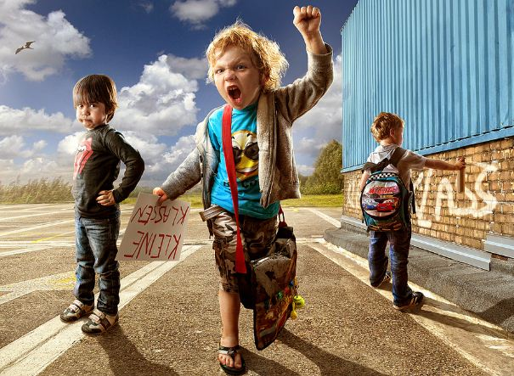

Storytelling.
Look at the pictures.
You are a TV producer who wants to create a new cartoon for children.
Look at the pictures and order them to make a story. Tell the story to your classmates.

- b) c)
