I am proud of being Ukrainian!

‘He, who loves not his country, can love nothing’
G. Byron
nique and beloved my native land, my Motherland – Ukraine – where I was born fourteen years ago. And I would like to say that I am thankful to God for this gift to be born in a country which I really love!
ind-hearted, friendly and hospitable Ukrainian people are known all over the world. The Ukrainians are well-known for their hospitable nature. One of the oldest traditions is to meet guests with bread and salt, saying ‘Welcome!’ We tend to have determined characters: we are very industrious and practical. In fact, we have got strong wills: we would survive in any place in the world even in the poorest of conditions. At the same time we are extremely warm-hearted, sociable and very good-humoured.
ich Ukrainian cuisine is very delicious. Who hasn’t heard about our famous dishes such as varenyky, with different fillings, holubtsi, pyrogy, uzvar, pampushky and, of course, borshch, the main dish of the Ukrainian cuisine. These Ukrainian dishes are very popular and some of them have no analogues in the world.
ncient cathedrals and churches, museums and monuments, many historical places are an integral part of a long Ukrainian history. It is an amazing country with a lot of things to see and to do. Once you visit Ukraine, you’ll be really enchanted by the country forever.
ndependence for Ukraine has come through hardship. During many centuries Ukraine fought against the Turkish-Tatar invasion and oppression of the Lithuanian and Polish lords. The Ukrainian people defended their independence and national culture.
ature of Ukraine is famous for its spectacular views, shady green woods, glittering lakes, deep blue seas, endless steppes and beautiful mountains. The best place to rest and enjoy yourself all the year round is the Carpathians. They are the marvelous treasury of Ukraine.
mbroidery for me is the most fascinating thing in Ukraine. It is a classical aspect of the Ukrainian folk art that exposes an inexhaustible source of popular creative work. It is widely spread in various variants as cloth ornament and interior. There is no house in Ukraine without embroidery.

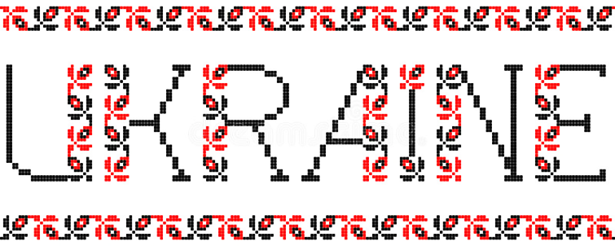 is a wonderful country to live in, enjoy its beauty, share the glory of the past days and great changes that are taking place now!

Devoted to Ukraine
Nastia Balaniuk
9th Form

