Vocabulary and speaking
Task 1
A. Match the questions with the answers.
1. What’s your e-mail? a. T-I-M-O-T-H-Y
2. How do you spell your name? b. Tommy@yahoo.com
3. What’s the time? c. OK then.
4. What about eight? d. It’s half past eight.
5. Check this out! e. It’s fantastic!
6. Are you James? f. No, I’m not.

B. Practice with your partner. Ask questions 1-6 to your partner. Then change your roles.

Exercise 1
Fill in the gaps in the table with the correct nationality. Mind your spelling.

Country | Nationality | Country | Nationality
Italy | Italian | Mexico | Mexican
Brazil | Brazilian | Canada
Egypt | Egyptian | Latvia
Estonia |  | Georgia
India |  | China | Chinese
Spain | Spanish | Japan
Poland | Polish | Portugal
Scotland |  | Greece | Greek
Denmark |  | France
Finland |  | Germany

Remember!
the United States of America (the USA) – American
the United Kingdom of Great Britain and Northern Ireland – British

Exercise 2
Find 13 nationalities and write them down. (The words might be located ↑↓←→↘↙)

A | S | D | E | R | T | Y | H | J | K | L | O | G | L | K | J | H | N | B | V
B | N | T | E | G | H | A | S | S | D | F | K | R | G | T | Y | H | J | S | F
A | S | I | T | A | L | I | A | N | F | R | H | E | I | K | U | H | M | N | T
K | P | L | D | F | G | H | J | K | G | R | F | E | D | S | W | Q | E | J | J
D | F | G | H | J | K | L | U | Y | T | E | D | K | W | D | G | H | X | K | A
S | N | A | I | D | A | N | A | C | A | S | O | A | W | G | H | K | I | F | P
H | F | D | Q | R | T | Y | K | L | M | N | B | A | F | N | Y | I | C | A | A
L | R | T | S | B | N | H | R | F | G | Q | E | T | G | H | J | H | A | A | N
P | O | I | U | Y | T | R | E | W | Q | A | S | D | A | I | D | E | N | G | E
O | I | J | G | N | A | I | T | P | Y | G | E | D | E | A | A | A | C | V | S
Q | E | T | U | O | P | L | N | G | C | S | A | S | W | D | F | N | A | Q | E
A | M | S | N | B | F | R | E | D | H | J | E | A | Q | W | E | R | T | Y | F
J | A | U | P | B | G | I | O | R | T | N | K | P | L | D | F | G | H | J | J
A | S | P | P | A | P | H | J | F | I | Y | U | I | P | O | L | I | S | H | G
N | O | P | T | Y | N | H | J | H | V | W | E | X | A | Q | U | T | G | D | F
A | L | P | O | M | G | I | C | A | D | H | T | I | E | N | G | F | T | O | N
M | K | N | E | O | I | F | S | L | O | C | A | U | T | O | E | R | G | H | J
R | H | R | I | O | N | C | A | H | Y | P | O | E | H | C | N | E | R | F | W
E | G | J | O | I | A | S | D | F | G | T | B | I | O | P | N | V | F | D | S
G | H | P | O | K | M | N | T | B | R | A | Z | I | L | I | A | N | I | G | H

- ___________________________
- ___________________________
- ___________________________
- ___________________________
- ___________________________
- ___________________________
- ___________________________
- ___________________________
- ___________________________
- ___________________________
- ___________________________
- ___________________________
- ___________________________

Game

You are taking part in the competition “Around the world”. Play in teams or individually.

1st ROUND
Name the countries and nationalities from the presentation “Flags”. The quicker you name, the higher your score is. The quickest student wins.
Bonuses: name more countries and nationalities and the referee then will subtract 3 seconds per each country and nationality form your score.
Penalties: one mistake adds 3 seconds per each country and nationality to your score.

2^{d} ROUND
Name famous facts about every country from the presentation “Flags”.
Example: Italian pizza is very tasty. German cars are the fastest etc.
One correct sentence gives one point to your score.
Bonuses: name more famous facts about the country and the referee will add 3 seconds per each fact to your score.
Penalties: one mistake subtracts 1 point per fact from your score.

Reading

Task 1

Have you ever been to the United States of America?
If yes, what did you like about it? If not, what do you know about the USA?
- Before you read, discuss the title with your partner. What will the text be about?

In the United States there are about 300 million people. Many of them come from other countries.
These people bring their culture with them: their food, music, etc. The US is called a ‘melting pot’
because so many different people live together as one.
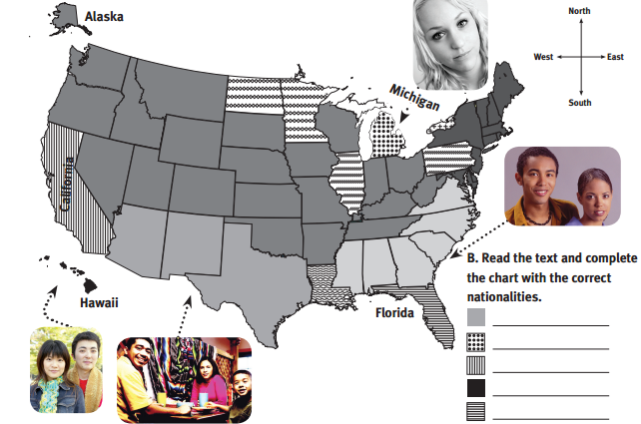
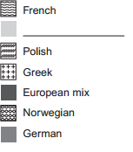
People from Germany mainly live in the central and northern parts of the US. In the southwest, there are many Mexican people, and in the southeast, there are a lot of African-Americans. On the northeast coast, there are many Europeans.
There are a lot of French people in Louisiana. New York has a lot of Greeks. California has a lot of Chinese people and Hawaii has many Japanese. Michigan has a lot of Dutch people, and North Dakota and Minnesota have Norwegians. Illinois and Pennsylvania have many Polish people, and Florida has a lot of Cubans and Puerto Ricans.

School subjects

Exercise 1

- Match the subjects 1-7 with actions a-h.
- Science a) I can find a country on the map
- Music b) I can calculate 254+658
- Art c) In 1953 Elizabeth II became the Queen of the UK
- PE d) H2O is water
- English e) There are seven notes: do-re-mi-fa
- History f) I can draw well and I am really creative
- Math g) I can name 5 games with the ball: football, basketball
- Geography h) You have to spell live with “v”, not with “f”.

b) Cover the right column and describe each subject to your partner. Do not tell the name of the subject. Your partner should guess the subject.

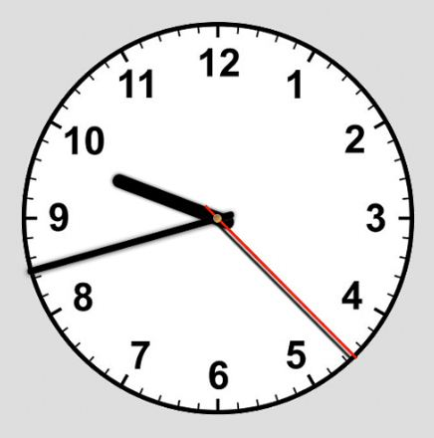
Exercise 2
What’s the time?
Write your timetable. What time does each lesson start?
1.____________________________
2. ____________________________
3. ____________________________
4.____________________________
5.____________________________
6.____________________________

When do you have breaks?
1.____________________________
2. ____________________________
3. ____________________________
4.____________________________
5.____________________________

Exercise 3

Work with your partner. Look at your school timetable. Model the dialogue:
Example:
You: When do you have PE?
Your partner: PE is on Monday.
You: When does the lesson start?
Your partner: Half past twelve.
You: When does the lesson finish?
Your partner: Quarter past one.

Grammar

Exercise 1
Complete the table with the correct form of the verb ‘be’. Use contractions.
 | + | - | ?
I
He/She/It
You
We
They

Exercise 2
Rewrite the sentences in ‘?‘ and ‘-’ forms.
- Jake and Michael are English.
? ____________________________________________________
- ____________________________________________________

- Mike is a British student.
? ____________________________________________________
- ____________________________________________________

- Lily is a new student from the USA.
? ____________________________________________________
- ____________________________________________________

- I am from Italy and my brother is Polish.
? ____________________________________________________
- ____________________________________________________

Exercise 3
Fill in using the verb ‘be’ in the correct form.

      - (-) You ________ Egyptian.
      - (+) She________ here.
- (?) He________ your brother.
- (+) We________ friends.
- (-) He________ nurse.
- (?) Maya________ from Canada.
- (+) Pupils________ classroom.
- (?) Teacher________ classroom.
- (+) I________ late.
- (-) Jake and Jil________ twins.
- (+) Havier________ Spanish.

Speaking

Work with your partner. Choose one of the famous people from the list below and guess the name by asking not more than ten Yes/No questions.

Example:
Is he a man?
Is she a woman?
Is he/she Ukrainian?
Is he/she a sportsman/woman? etc.
Svyatoslav Vakarchuk
Potap
Tom Cruise
Brad Pitt
Lilia Podkopaeva
Yana Klotchkova
Tina Karol
Jamala
Olga Sumska
Olga Kurilenko
Volodymyr Zelenskiy
Bohdan Stupka
Lina Kostenko
Liubko Deresh

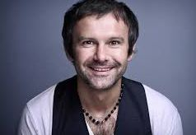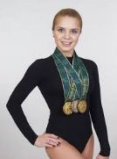
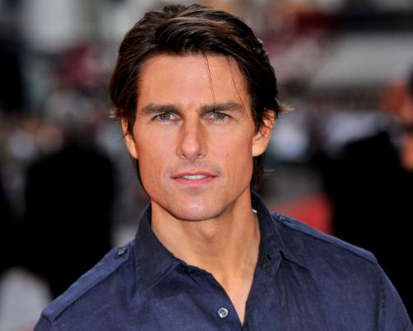

Grammar

‘Have got’
Exercise 1.
Rewrite the sentences in ‘?‘ and ‘-’ forms.
- Mary has got a little son.
? ____________________________________________________
- ____________________________________________________

- We have got a new teacher.
? _____________________z_______________________________
- ____________________________________________________

- My sister has got green eyes.
? ____________________________________________________
- ____________________________________________________

- Footballers have got a lot of fans.
? ____________________________________________________
- ____________________________________________________

- I have got three cousins.
? ____________________________________________________
- ____________________________________________________

- The Adam’s family has got three children.
? ____________________________________________________
- ____________________________________________________

- Sue has got a big collection of soft toys.
? ____________________________________________________
- ____________________________________________________

- Elephants have got big ears.
? ____________________________________________________
- ____________________________________________________

Exercise 2
Choose a or b.

1. Who is that? Is he _____ teacher?
a. your b. you
2. John Smith is here for the interview. _____ CV is on your desk.
a. His b. He’s
3. These are my _____ shoes.
a. brother b. brothers’
4. _____ houses are big.
a. They b. Their
5. Is a student at _____ university?
a. he b. his
6. A: _____ that?
B: It’s my new camera.
a. Who’s b. What’s
7. A: Is Kate an actress?
B: No, _____ a photographer.
a. he’s b. she’s

Speaking+ Writing

Task 1
Interview as many your classmates as you can within 2 min. Fill in the table and make notes. Be ready to present information to the teacher.

Have you got…? | Name | Name | Name
a sibling
some chocolate
a pet
a bus ticket
an apple

Task 2

What does he/she look like?
- Choose one of your classmates. Describe him/her to your classmates, but do not tell them his/her name. Classmates should guess the name.
- Work with your partner. Describe your classmate. Tell him/her about your classmate’s eye colour and size, hair length and colour, and clothes. Your partner listens to your instructions and draws a portrait. When you finish, your partner guesses the name of your classmate.
- Choose another person and write down his/her description below. Write 5-8 sentences.
_______________________________________________________________________________________________________________________________________________________________________________________________________________________________________________________________________________________________________________________________________________________________________________________________________________________________________________________________________________________________________________________________________________________________________________________________________________________________________________________________________________________________________________________________________________________________________________________________________________________________________________________________________________________________________________________________________________________________________
Project
My family tree
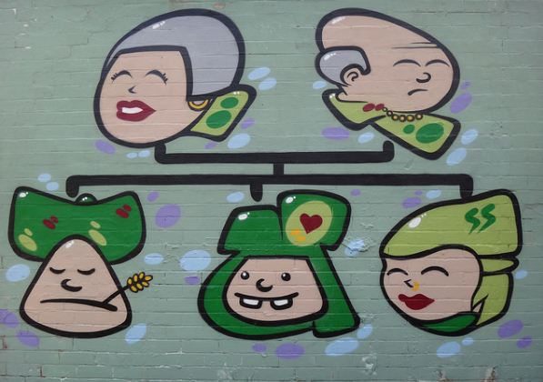
Make a poster of your family tree. Include information about 5-10 relatives. Present information about:
My Family | Example
- Relative | uncle
- Name | Taras
- Age | 32
- Profession | doctor
- Hobbies | football

My things
Work with your partner. Look at the picture of the room. Describe it to your partner. Tell him/her about the size and the colours of the room, its furniture and feelings. Then listen to your partner and make notes about his room.
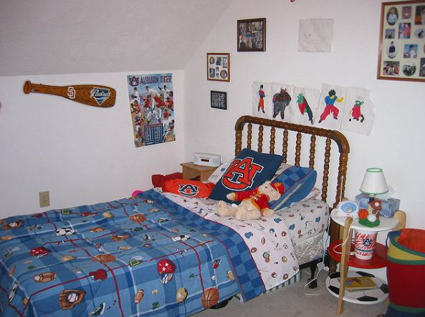
Your partner’s room B
Size: big or little?
Colours
Furniture
Does he/she like the room?

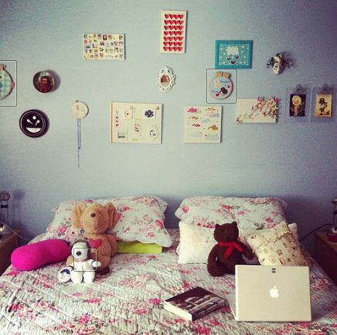
Your partner’s room А
Size: big or little?
Colours
Furniture
Does he/she like the room?

Reading

Task 1
Do you know what do naturalists do? Read the text and check your answers.
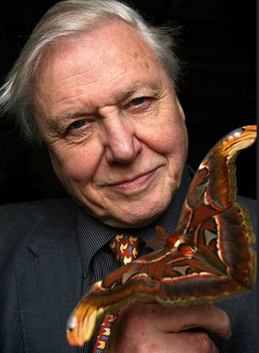
Sir David Frederick Attenborough is a famous British naturalist and TV-presenter. He has his own TV-show about animal world. He is very famous in the UK and in the all world. He loves animals and nature and makes TV-programs about them. He loves animals and wants to tell about them to other people. You can watch his shows on BBC channel or on YouTube. He has got a lot of fans in different countries and Ukraine too!

Answer the questions

- Who is David Attenborough?
- Where does he come from?
- Does he like animals?
- Where can you watch his programs?
- Has he got a lot of fans?

Video
Before you watch
What animal, insect or bird would you like to be alike? What does it look like? Why do you like it?

Check the list of animals, insects and birds. Tick all words that you know. Check unknown words with your teacher.

Grasshopper
owl
sea-gull
dog
hippo
tortoise
polar bear
dragonfly
cat
lion
chimpanzee
orangutang
buffalo
penguin
ostrich
meerkat
sea horse
elephant
parrot
humming bird
seal
jelly fish
butterfly
frog
dog
whale

Watch the video

You are going to watch a video “What A Wonderful World” with David Attenborough
https://www.youtube.com/watch?v=auSo1MyWf8g .
Circle the animal, insects or birds that you will see in the video. Some of them are not in the video.

Listen to the song once more and fill in the gaps with the words from the box.
wonderful pretty blue people hands hear know green you wonderful night think wonderful love

I see trees of _____, red roses too
I see them bloom for me and _____
And I think to myself what a _______ world.
I see skies of _____ and clouds of white
The bright blessed day, the dark sacred _____
And I think to myself what a __________ world.
The colors of the rainbow so ______ in the sky
Are also on the faces of _______ going by
I see friends shaking ______ saying how do you do
But they're really saying I ______ you.
I ______ baby's cry, and I watched them grow
They'll learn much more than I'll ever ______
And I _____ to myself what a wonderful world.
Yes, I think to myself what a _______ world.

Game
Split into two teams. One player chooses an animal, insect or bird from the list and mimes it to his/her team. The player has 30 seconds to show the animal, insect or bird. If the team guesses, it gets a point. If the answer is wrong, nobody gets a point.

Grammar

Exercise1
Put the verbs in brackets into Present Simple.
1. Mike usually ________ (hang) out with friends after school.
2.How often ________ you ________ (go) to the cinema?
3. ________ they ________ (work) on Sundays?
4. Wendy never ________ (do) her homework on Fridays.
5.Joanna ________ (spend) many hours watching TV. She ________ (not like) going out.

Exercise 2
Put the adverbs of frequency in the correct place.
1. My friends surf the Net. (often)
2. We watch downloaded TV programmes. (never)
3. Marcus helps his sister with the housework. (usually)
4. Miranda is at home in the mornings. (rarely)

Exercise 3
Complete the sentences with the correct form of the verbs below.
get up watch check spend go
1. I can’t stand ________ animated films.
2. I hate________ early in the morning.
3. Would you like________ shopping with me?
4.I love ________ time with my friends at the gym.
5. He enjoys ________ his e-mails at night.

Exercise 4
Choose a or b
- Jenny________ in this room with the other reporters.
a. work b. works
2. Where________ people ________ dinner?
a. do … have b. does … have
3. My sister ________ her work at nine.
a. starts b. start
4. Eddie________ horror films, so he never watches them.
a. don’t like b. doesn’t like
5. How often ________ Stacey________ sports?
a. do … play b. does … play
6. Ian rarely goes to the cinema ________ Fridays.
a. during b. on
7. ________ the weekends, I usually sleep ________ eleven o’clock in the morning
- In … at b. At … until

Exercise 5
Open the brackets and put the verbs into the Present Simple Tense.
- He always ______ (pass) all exams.
- I never ______ (play) table tennis in winter, only in summer.
- Andrew ______(take) his dog for a walk to the park every morning.
- July _______ (not make) a model plane, but her brother ____ ( do) and _____ (fly) the plane.
- Brian ______ (watch) TV after school and _____(not go) to the dance class.
- What ______ (you, do) after school on Fridays?
- ________ Lucy _____ (go) to the dance class?
- ______ you usually ______(read) comics at weekends?
- _______ Sarah ______ (go) to the park every day?
- I always ______ (go) out with friends on Sunday.

Exercise 6
Translate the following sentences into English.
- По понеділках я ходжу в кіно з братом. Ми вибираємо новий фільм, купуємо багато попкорну та обговорюємо його після перегляду.
- В моєму улюбленому фільмі головний герой грає в комп’ютерні ігри кожного дня.
- В мультиках тварини зазвичай поводять себе як люди: ходять в школу, грають в ігри, їздять на велосипеді.
- Мій брат ходить до гуртка авіа моделювання. З понеділка по п’ятницю вони роблять моделі, а на вихідних їдуть за місто та запускають їх.
- Улюблені фільми мого найкращого друга – комедії. Головні герої дуже часто жартують і ніколи не плачуть.
- Моя мама не любить фантастичні фільми, а тато - романтичні, тому вони дуже рідко ходять в кіно разом.
- Фільми жахів не можна дивитися дітям, бо вони лякаються та не можуть спати вночі.
- В мюзиклах актори багато співають і танцюють, але інколи це виглядає безглуздо.
- Я дивлюся фільми всіх жанрів, окрім фільмів жахів. Не розумію, чому люди так люблять ці фільми.
- Ми з другом рідко ходимо в кіно, тому що дивимось фільми онлайн. Це безкоштовно та інші люди не заважають дивитися фільм.

Reading
Discuss.
• What do you like doing in your free time?
• Do you think teens in the US and Canada do the same activities in their free time?

Read the text and check your answers.
HOW DO TEENS IN THE US AND CANADA SPEND THEIR FREE TIME?
We asked 100 teens from Canada and the US to tell us what they like doing in their free time.

CANADA
45 of the 100 Canadian teens enjoy using the
computer in their free time. They like surfing
the Net, checking e-mails and playing online
games. 20 teens like watching films on TV. 12
of the 20 teens like adventure and comedy films
and 8 of the 20 like watching horror or science fiction films. 15 of the 100 teens love listening
to music in their free time. 12 teens enjoy going
shopping and 8 like going to the gym.
USA
42 of the 100 US teens like listening to music
in their free time. 20 of the 42 teens love pop
music, 15 like rock and 7 like listening to hip
hop. 30 of the 100 teens like watching films on
TV. 15 teens like using the computer in their
free time. 8 of the 15 like surfing the Net and 7
love checking their e-mails. 10 of the 100 teens
enjoy spending time with friends and 3 like
staying at home.

Read the text again and fill in the tables.
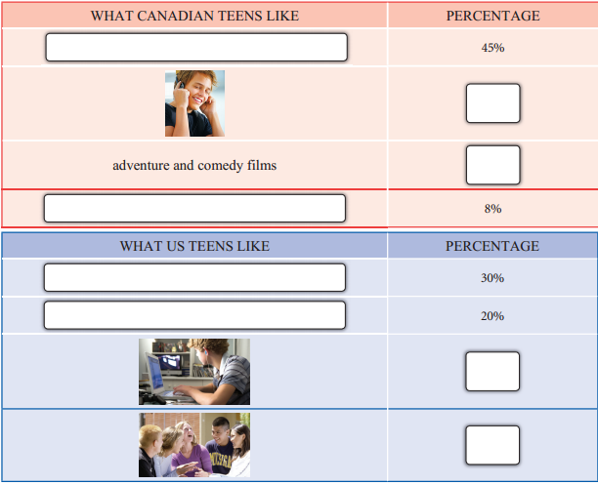

Reading

Who are you?

Choose one celebrity. Tell your partner about a typical day of your celebrity. Name three activities that he does and doesn’t do.
Justin Timberlake (01/ 31/1981) is an American singer, songwriter, actor and record producer. He started his career in TV-show for children, than he was one of the lead singers in the boys band NSYNC. In present time Justin is very popular in the USA and in the all world. He gives many concerts, works with young talents, shoots in Hollywood films.

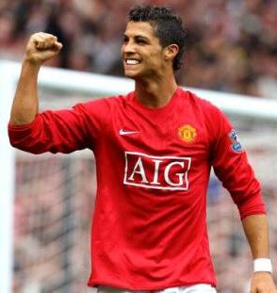
Cristiano Ronaldo (02/05/1981) is a Portugal footballer. He is famous as the most expensive footballer of all times and he played in so many games, as no other footballer. He was the best youngest football player in Euro Cup 2004. He has got many football awards and he is famous all over the world. At the moment he is a member of Real Madrid FC.

Bill Gates (10/28/1955) is an American businessman and ex-director of the Microsoft Co. In 1996-2007 Mr. Gates was the richest person of the planet. He and his wife created a charitable fund and want all millionaires to donate half of their money for charity.
At the moment Mr. Gates has several companies and takes care of his charitable fund.

Speaking!
Movie time!
Work with your partner. Choose one of the film genres. Tell your partner about places, characters, events for that are typical for this genre. Your partner should guess the genre.
Example: Fantasy is a film about unreal events in fantastic country.
      - Science-fiction
- An animated film
- An adventure film
- A horror film
- A comedy
- A romantic film
Interview your partner and be ready to share his/her answers with the class:
- What kind of films do you like? Explain and give examples.
- Do you prefer to watch films at home or at the cinema? Why?
- How often do you go to the cinema? Who do you go with?
- Do you take any snacks or drinks with you? What are they?
- Do you usually watch films more than once?
- Do you think it is OK to upload films and share them with others without paying for them?
- Would you like to be a famous film star? Why/why not?

Project
Moviemakers!
You are going to work in a team to produce your own film.
Procedure:
- Choose one of the following movie genres and create your own plot for it.
- Science-fiction
- An animated film
- An adventure film
- A horror film
- A comedy
- A romantic film
- Discuss with your team members:
- the place and characters
- the money you will need for filming
- the reason to watch your film?
- Create a presentation of your film project and present it to your class. Add a short trailer of your film to it.
- Vote to choose the best project. You cannot vote for your team.

The best room!
- Choose one of the pictures below and put down 5 sentences to describe it. Do not name the room. Read your description to your classmates and let them guess the room.
- Choose one of the pictures below. Choose one object in the picture. Do not name it. Tell your classmates where it stands/lies/hangs. Let them guess the object.
Room 1
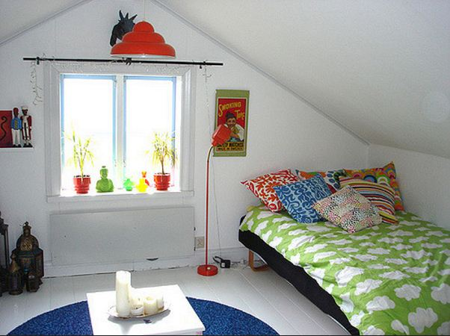
Room 2
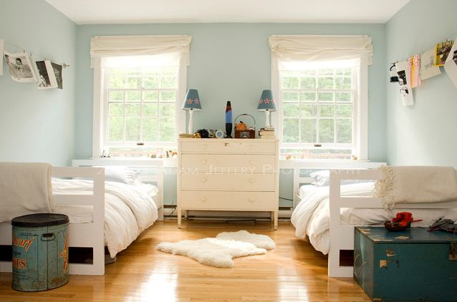
Room 3

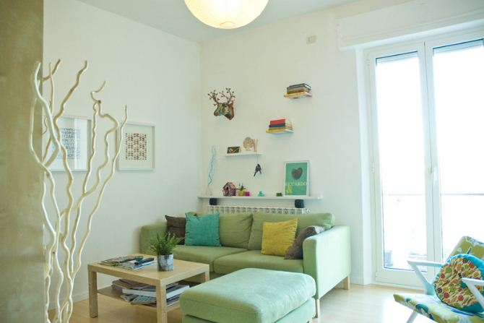
Room 4

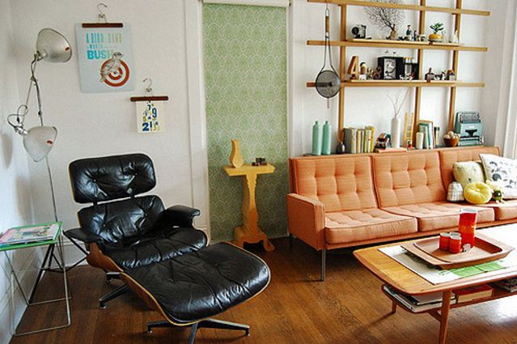
Room 5
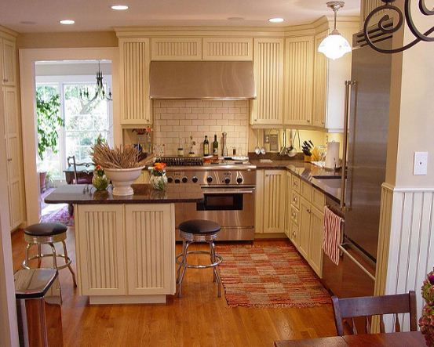
Room 6
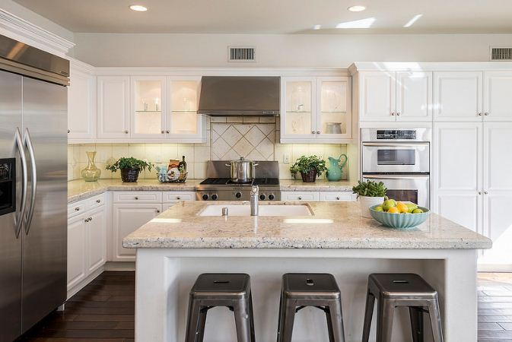
Grammar
Exercise 1. Give a short answer to the following questions.
Can David play the piano? – Yes, he can.
- Can David show the Police Station? No, _____________________________________
- Can you swim? No, ______________________________________________________
- Can Ann use washing machine? Yes, ________________________________________
- Can they speak French? Yes, ______________________________________________
- Can we use the cooker now? _______________________________________________
Exercise 2. Make questions with can.
E.g.: John is 5, but he has many books.
(read) Can he read?
- John learns how to play the piano.
(what/play) ____________________________________________________________
- My brother wants to be a racer.
(drive) _________________________________________________________________
- My sister’s going to the UK.
(speak/English) __________________________________________________________
- I have a new computer.
(surf the Internet) ________________________________________________________
- I want to paint your portrait.
(paint) _________________________________________________________________
Exercise 3. Fill in the sentences with the information about you. Use can /can’t.
- I ___________ drive.
- I ___________ paint a picture.
- I ___________ type.
- I ___________ swim.
- I ___________ use a computer.
- I ___________make a party.
- I ___________ speak French.
- I ___________ clean.
- I ___________ speak English.
- I ___________ drive a car.
- I ___________ use the Internet.
Exercise 4. Write more sentences about things you can and can’t do.
- _________________________________________________
- _________________________________________________
- _________________________________________________
- _________________________________________________
- _________________________________________________
Exercise 5. What can or can’t people of different age do?
Work individually and fill in the table using ‘+’, ‘-‘ or ‘+/-‘. Compare your answers with your partner.

 | Baby | Toddler | Student | Middle age | Elderly
speak

walk

crawl

get married

work

live alone

eat/drink yourself

study

google

use computer

Reading
Discuss.
Do you know any famous sights in London? What do you know about them?
Read the text, indicate the route of the Super Bus London Tour and label the places 1-4 on the map.
